Issue Brief
Elizabeth Mugo and Ryan Ruggiero June 2024

Advancing Family Economic Mobility in Mississippi Through a Peer-to-Peer Statewide Learning Network
Advancing Family Economic Mobility is an initiative led by the American Public Human Services Association (APHSA). As part of this initiative, APHSA partnered with the W.K. Kellogg Foundation (WKKF) to mobilize state leaders in human services to improve economic mobility for children and families across Mississippi, one of the poorest states in the country. In 2022, APHSA worked with the Mississippi Department of Human Services to establish the Mississippi Action Learning Network (MALN), a statewide peer-to-peer learning community for public and private leaders.
This brief describes the activities of the MALN, from May 2022 through December 2023. It includes takeaways related to: (1) how the learning community’s facilitators planned and facilitated meetings, (2) meeting attendance, (3) how sharing and learning took place, (4) what participants learned and examples of how they collaborated, and (5) progress the MALN made toward its goals. Mathematica evaluated the MALN by observing its meetings, conducting focus groups with the facilitators, interviewing selected MALN members, and administering surveys to members. A section on methodology at the end of the brief has more information.

Key takeaways
- Planning and facilitating meetings required the facilitators to establish trust with MALN members to develop a safe meeting culture. Facilitators also worked with members to develop a shared future state with a road map for how to get there. See page 4 for more information.
- Twenty members from 11 agencies participated in the Mississippi Action Learning Network (MALN), and an average of six members from multiple agencies attended each meeting. Members of the MALN were motivated to attend meetings to build relationships with other leaders outside times of crisis, to align resources with other agencies, and to share and learn from each other to improve economic outcomes for Mississippians. See page 7 for more information.
- MALN members reported that an open and honest meeting culture and meeting in person promoted sharing and learning with their peers. See page 9 for more information.
- By attending MALN meetings, members reported an increase in their understanding of best practices, innovations, and policy options to advance economic mobility, including learning more about the work of other agencies. See page 9 for more information.
- Members reported making progress on the MALN roadmap, with the most progress in the generative leadership priority area. Five out of six survey respondents agreed or strongly agreed that participating in the MALN increased their agency’s collaboration with at least one other MALN agency outside of MALN meetings. See page 11 for more information.

I. What is the Mississippi Action Learning Network?
How did partners support the work?
The W.K. Kellogg Foundation (WKKF) funded the role of the APHSA facilitators, including the cost of their travel to Mississippi and supports to facilitate meetings.
Facilitated by two American Public Human Services Association (APHSA) staff, the MALN is a statewide peer-to-peer partnership where Mississippi state leaders share and learn best practices, innovations, and solutions for improving economic mobility. The purpose of this learning network is to bring together public and private leaders for cross-agency peer learning to advance economic mobility for families in Mississippi. The ultimate goal is to advance family economic mobility for all Mississippians by aligning public and private leaders’ values and priorities to equitably change the human services system. Key planned activities of the learning community include (1) facilitators plan and facilitate meetings; (2) members attend and share best practices, innovations, and solutions with each other; and (3) facilitators share resources and guide development of a road map, that describes planned MALN member activities. As described in Figure 1, the facilitators believe that by engaging in these activities, public-private leaders in Mississippi—from human service agencies, workforce agencies, businesses, nonprofits, philanthropic organizations, families, and federal partners—will make changes to improve economic mobility for Mississippians.
Figure 1. Theory of change
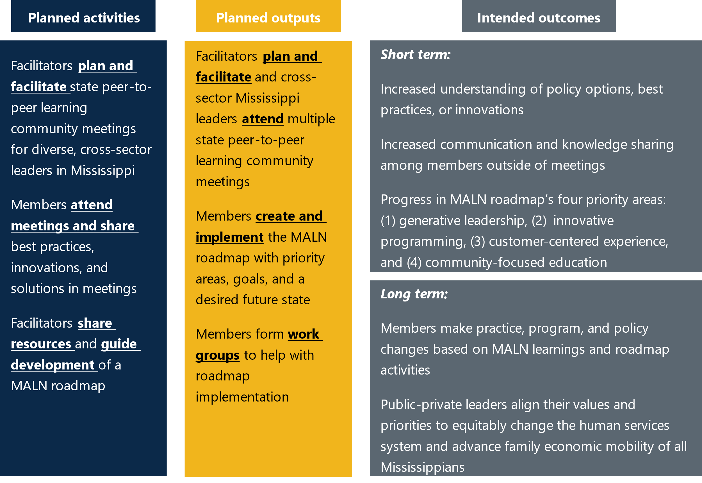
Note: The MALN facilitators defined generative leadership as, “leaders who enrich the human experience by building great cultures, organizations, and systems. Generative leaders value a sense of belonging and purpose that is bigger than themselves.”

How was the MALN started?
In 2019, staff from the WKKF and APHSA conducted a one-year planning period in partnership with the Mississippi Department of Human Services (MDHS) to better understand how state and local agencies worked together to support Mississippi families, including the successes and challenges they faced. APHSA also explored issues of trust within and outside of MDHS, following the agency’s misappropriation of Temporary Assistance for Needy Families (TANF) funds in previous years.
During the planning period, APHSA and WKKF staff conducted interviews, focus groups, and surveys with various state, local, and community agencies, including MDHS service recipients. Based on their finding that the state needed to better align its systems, APHSA and MDHS established the MALN, which held its first meeting in May 2022.
Changing the human services system in Mississippi
The MALN aims to advance family economic mobility in Mississippi by changing the human services system in their state. To assess the MALN’s readiness for systems change, Mathematica distributed a survey to members one year into the initiative. The survey was meant to assess the partnership’s strengths and areas for improvement related to factors likely to help a partnership achieve systems change.
The assessment was designed for partnerships that have been active for many years. Because the MALN is a new initiative, the survey helped members identify areas to focus on in the future. The survey results showed that the MALN is making progress in several areas.
What is systems change? Systems change initiatives aim to shift the conditions that hold a problem in place by changing policies, practices, resource flows, relationships and connections, power dynamics, and mental models (deeply held beliefs and thoughts).
Three out of four survey respondents reported that the MALN had many strengths, including the following:
- Creating a vision statement identifying what the partnership seeks to achieve
- Trusting and holding each other accountable in implementing activities as planned
- Developing structures and processes that facilitate active and genuine partner engagement
- Investing, building, and maintaining the capacity of its partners
- Promoting and supporting positive and culturally responsive learning environments
Three out of four survey respondents reported that the MALN had room to grow in the following areas:
- Having a concrete and comprehensive strategic plan to improve outcomes for Mississippians
- Involving Mississippians most directly impacted by the work in MALN decisions and plans
- Advancing a strengths-based narrative about Mississippians to shift mindsets in the community
- Establishing norms and cohesive systems for data collection and reporting across partner agencies

II. How did facilitators plan and facilitate meetings?
APHSA facilitators planned and facilitated eight in-person MALN meetings, not including initial smaller group meetings, at MDHS during a 15-month period from September 2022 to December 2023. They utilized the Design, Assess, Plan, Implement, and Monitor (DAPIM™) framework—a continuous quality improvement process—to inform their work.
The APHSA facilitators are organizational effectiveness consultants who have extensive experience facilitating discussions to support the work of agencies from a systems perspective. Their main role was to facilitate meetings, including helping members identify priorities for the group, providing a structure and space for MALN members to connect with each other, and helping members develop relationships with each other. Facilitators supported MALN meetings by coordinating meetings with members’ schedules, sending out calendar invitations, and drafting meeting agendas. The facilitators and APHSA’s research staff also researched topics of interest to MALN members and developed materials for MALN members such as infographics and summaries on meeting topics, such as using TANF funds for transportation. Facilitators also took notes during meetings and regularly distributed meeting notes and materials to the MALN members after the meetings.
“[Facilitators have] been really good about sharing the notes from the last meeting and where we are, providing us with research from other states and best practices. And sharing that ahead of time helps drive the talking points.”
— MALN member

What is the MALN road map?
Created by members, the MALN road map includes four priority areas and describes activities MALN members will undertake to achieve their desired future state. Facilitators update the road map as members make progress within each priority area. Each area also includes a vision statement as described below:
- Priority Area 1: Generative leadership. Cross-sector leaders collaborate, leading to actionable changes within Mississippi’s health and human services system.
- Priority Area 2: Innovative programming. Community-centered programming incorporates the voice of service participants throughout Mississippi.
- Priority Area 3: Customer-centered experience. Mississippians are met with a harmonious and accessible customer experience throughout the state, reflecting the strengths of each community, while exploring the incorporation of mobile service delivery.
- Priority Area 4: Community-focused education. Educational experiences happen within the community and reflect a cross-sector perspective.
The following takeaways describe how facilitators planned MALN meetings and their recommendations for how to promote sharing and learning during meetings:
Develop a shared future state alongside members, with a road map for how to get there. A key role of the facilitators in the first year was to collaborate with MALN members to develop a desired future state and road map, to help the group identify goals and action steps. The facilitators said they modelled “inclusive facilitation” in developing the road map and in MALN meetings to show members how to identify goals and recognize the importance of hearing from their staff and the community. Facilitators used the first several MALN meetings to develop the desired future state and road map, which laid the groundwork and direction for future meeting topics. The desired future state outlines what Mississippi will look like when the MALN has advanced family economic mobility through implementation of the road map. MALN meetings involved reviewing the road map and action items to check whether the group’s priorities remained the same.
Ensure that members’ knowledge and interests inform meeting agendas. After the goals of the MALN were established, facilitators determined the agenda topics based on the interests of MALN members. The facilitators said they viewed MALN members as experts and relied on them to drive meeting topics, which informed the development of the agendas. Facilitators ended meetings by asking members what they wanted to discuss during the next meeting. This allowed them to prepare for the next meeting and be responsive to the evolving needs and interests of the group. For example, in one MALN meeting, members said they were interested in learning more about how to use TANF funds for transportation, so the facilitators planned a meeting focused on this topic.
“MALN members know themselves best. The facilitator has to see it and help them get to that. It should be participant-driven, facilitator-led work. And recognizing that you have to be on your toes—the agenda might have to be changed after the meeting starts. You’re meeting them where they are and where they want to go.”
— MALN facilitator

At the first MALN meeting, facilitators gave members time to share and connect with each other at the start. They did not intend to begin future meetings this way. However, based on member feedback, facilitators adjusted the meeting schedules to allow time for sharing recent agency initiatives, including successes and challenges, at the beginning of every meeting.
Establish trust between facilitators and MALN members to develop a safe meeting culture. Facilitators said that developing a good relationship between themselves and MALN members played a key role in creating a safe space for members to share agency challenges with each other. Facilitators developed this relationship through listening to MALN members, letting them lead the work, and understanding the context of Mississippi. They also asked critical questions to probe further during meetings, rather than telling members what to do.
“[The facilitators] have been so helpful, quick to respond, very professional, easy to work with—the type of people that you enjoy being in a meeting with…. You have a room full of alpha dogs and they do a great job keeping us on track and making sure everyone is heard and personalities don’t dominate.”
— MALN member

The facilitators initially planned to include a local facilitator from Mississippi to support their meeting planning and facilitation. However, MALN members decided not to pursue a local facilitator because they developed a good relationship with the APHSA facilitators and trusted them to facilitate meetings as a neutral party.

III. Who attended MALN meetings?
Prior to starting the MALN, APHSA provided technical assistance to MDHS staff in organizational culture and internal workforce. In preparing for the first MALN meeting, APHSA facilitators asked MDHS leadership whom to invite to join the network. They recommended partnering with leaders from Child Protective Services, the Department of Health, and Workforce Development. MDHS leadership considered these agencies key leaders in advancing family economic mobility in the state.
Initially, APHSA intended that this small group of agency leaders, including MDHS, would develop a road map to define the focus of the initiative as well as their planned activities and goals. However, after five state agency leaders met for two meetings in spring and summer 2022, they decided that a larger group should determine the MALN’s priorities. Invitations were extended to additional agencies to join the MALN.
Meetings occurred about every six weeks. The facilitators sent polls to invited members to determine their availability for the next meeting day and time. After the meeting date was determined, facilitators sent notice to members at least one month before each meeting. Facilitators also encouraged members to send another representative from their organization when they could not attend meetings.
MALN member agencies
The first two meetings included agency leaders from five agencies: (1) MDHS, (2) Division of Medicaid, (3) Accelerate Mississippi, (4) Department of Health, and (5) Child Protective Services.
The group expanded to include leadership from six additional agencies and organizations: (1) Children’s Foundation of Mississippi, (2) Community College Board, (3) Department of Corrections, (4) Department of Employment Security, (5) Department of Mental Health, and (6) Department of Rehabilitation Services.
MALN members largely represented state agencies. The group has not yet expanded to include most other sectors. The desired future state of the MALN is a public-private partnership that includes businesses, nonprofits, philanthropic organizations, and families, among other partners. However, nine out of 11 MALN agencies were state agencies and two were nonprofit organizations (NPOs). MALN members have not yet invited private partners such as philanthropic organizations, businesses, or families to attend meetings. Although the group has primarily focused on connecting state agencies, the agencies represented different sectors—including, health, child protective services, and corrections. Overall, MALN members and facilitators said they were satisfied with the diversity of agencies in the MALN. Facilitators and members mentioned difficulties with engaging other state agencies to join the MALN. In one case, facilitators mentioned how a change in an appointed state agency position was a challenge. However, MALN members and facilitators did not report any rationale on why other agency leaders chose not to join the MALN.
Five MALN agencies attended more than half of the meetings, but the individuals who attended each meeting varied. As shown in Figure 2, of the 11 agencies or organizations in the MALN, three agencies were represented at one or two meetings (27 percent), three agencies were represented at three or four meetings (27 percent), and five agencies were represented at five or more meetings (45 percent). Although about half of the agencies (five) attended more than half of the meetings (five or more), the individual attendees varied because agency leaders sent representatives when they were unable to attend. A total of 20 members attended at least one MALN meeting between September 2022 and December 2023, with an average of six members in each meeting. Of these 20 members, 10 members (50 percent) attended only one meeting, three members (15 percent) attended two meetings, and seven members (35 percent) attended three or more meetings. Mississippi state agency leaders who attended meetings included executive directors, directors, and deputy directors.
Figure 2. Types of participants and their attendance rates
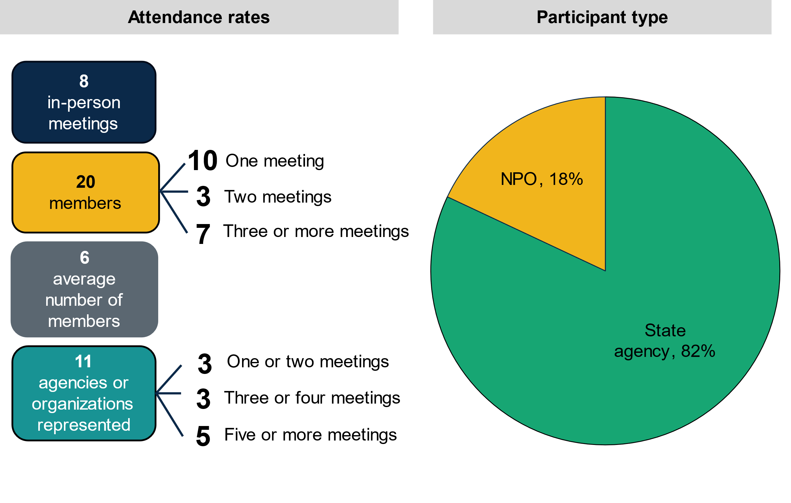
Note: Attendance records reflect MALN meeting attendance between September 2022 and December 2023 and do not include APHSA facilitators, who attended every meeting. NPO stands for nonprofit organization.
Meeting attendance made it challenging for facilitators to plan and facilitate meetings. Facilitators and MALN members both described challenges with meeting attendance. Facilitators said that attendance created challenges for planning and facilitating meetings because MALN members did not always respond to meeting invites or say when their availability changed. Facilitators noted that attendance affected their planning because lower attendance meant fewer members to share and discuss priorities and strategies to move the work of the road map forward.
Similarly, MALN members described workload and competing priorities as a challenge to attending meetings. Although seeing other agency and organization leaders at meetings motivated members to attend, all interviewed members shared that workload was often a barrier to attending meetings. MALN members said they have many demands on their time because of their agency leadership positions, which can make it difficult to attend MALN meetings. One member noted that meeting attendance often varied. One member suggested that having a respected agency leader reach out to MALN members may help increase attendance at meetings. “In Mississippi, it is hard to turn down a favor,” the member said. They believe that other agency leaders would be happy to do a favor when asked directly by another agency leader.

What motivated members to join the MALN and attend meetings?
When asked what motivated them to join the MALN and continue attending meetings, interviewed members emphasized building relationships with other members and leveraging state agency resources.
To build relationships with other state leaders outside times of crisis. Although interviewed MALN members had connected with other agency leaders through past work or the governor’s cabinet, they did not routinely come together before the MALN existed unless it was a time of crisis. Members joined the MALN as an opportunity to build relationships with other agency leaders and because they were interested in working together to better serve Mississippians. One MALN member noted the MALN allowed them to have conversations with other agencies focused on helping their clients, “without trying to get after one specific problem.”
“Bottom line, we all serve the same clients—the population of Mississippi. [The] opportunity to work together with outside ideas is what’s driven us to [join the MALN].”
— MALN member

To leverage and align resources with other state agencies and organizations. Before joining the MALN, interviewed members reported working in silos. They said that they joined the MALN to share resources across agencies and to discuss priorities in one venue. Facilitators also reported that agencies often provided similar services to communities without considering ways to collaborate or share resources. One member said no Mississippi agency had enough resources to serve all its clients without the support of other agencies. Several members highlighted the overlap in clients across agencies, which made it necessary for leaders to work together. One member shared that MALN meetings allowed them to maximize their interactions with other MALN members rather than meeting separately with each agency.
“The only way that we’re going to be able to serve the population the way [they] deserve is for us to pull together.”
— MALN member

To share and learn from other agencies and spur innovation. Interviewed members reported that having several agencies and organizations at MALN meetings allowed their agency the chance to share their work and learn about innovations based on others’ work. One MALN member said the meetings helped them stimulate their strategic thinking, look at areas of innovation that their agency could take advantage of, and “help eliminate some blind spots.”

IV. How did sharing and learning occur during meetings?
MALN meetings provided a space for members to share best practices, innovations, and solutions with each other in real time and to work toward the goals in their road map. Each meeting was in person, typically for two hours, and regularly included time for members to share updates on programs and services, challenges, opportunities for collaboration, and upcoming events. Facilitators often discussed a key topic of interest to members, sometimes inviting an outside speaker. They also reviewed the MALN road map and priorities in some meetings. Depending upon the conversation, facilitators sometimes shared handouts or other resources. Meetings often closed with identifying agenda items for the next meeting. Agenda topics included the use of TANF funding for transportation, personnel boards, and civil service salaries.
“It hasn’t just been sugarcoating and showing your best Sunday suit. It’s getting real about the challenges [we face] providing the good services our people need and deserve in a state with a low income.”
— MALN member

Interviewed MALN members said they were satisfied with the amount of sharing and learning occurring in meetings and did not mention any barriers to sharing and learning. One member noted, however, that takeaways shared from previous meetings were sometimes limited and did not capture the full content of the meeting.

What helped members share and learn during meetings?
In interviews, MALN members discussed what helped them share and learn during MALN meetings.
Meeting in person fostered trust between members. Both facilitators and interviewed members noted the importance of in-person meetings, which allowed members to build an atmosphere of trust. Facilitators said that face-to-face conversations were crucial for allowing members to be vulnerable, fully engage in conversations about their challenges, and learn from each other outside of their daily work. APHSA also provided breakfast or lunch at meetings, which gave members time to informally connect and continue to build relationships.
Open communication and an honest meeting culture. Interviewed members reported that open communication during meetings helped develop an honest and safe meeting culture. Sharing challenges, frustrations, and accomplishments with each other also helped develop trust within the group. Facilitators noted that members were willing to seek feedback and input from others, which allowed them to be transparent with each other. One member shared how open communication progressed as members formed relationships during the meetings. Facilitators said they were proud of members’ willingness to, “put their guard down,” and be open to learning from each other.
“We shared very openly our frustrations doing our work in a state that we love that is horribly underserved. We’ve gotten honest with each other which promotes trust and confidence in each other and it makes me more willing to work with someone.”
— MALN member

V. What did members learn during meetings?
One short-term outcome of attending MALN meetings is that by attending meetings, members will increase their understanding of policy options, best practices, or innovations related to economic mobility. In January 2024, Mathematica distributed an endline survey to MALN members. As shown in Figure 3, all six survey respondents agreed or strongly agreed that participating in the MALN increased their understanding of policy options, best practices, or innovations to improve the lives of Mississippians.
MALN members learned innovative ways to use TANF funds for transportation. All six survey respondents agreed or strongly agreed that participating in the MALN increased their understanding of this topic. Members reported learning about best practices from West Virginia and Louisiana in spending TANF funds to increase mobility. One member noted that Mississippians experience challenges with workforce participation and access to resources due to lack of transportation.
“Everybody knows that transportation is the most impactful and ubiquitous [barrier] among low-income Mississippians. And it gets in the way of everything, because we don’t have mass transportation resources to a significant degree.”
— MALN member

Figure 3. Knowledge gained by participating in the MALN
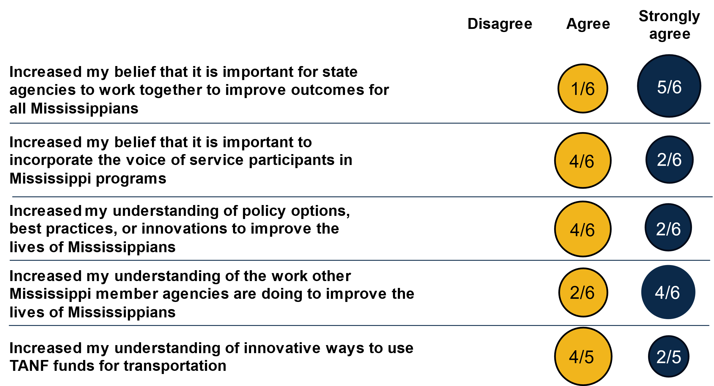
MALN members learned about other Mississippi member agencies, including their available services and programs. All six survey respondents agreed or strongly agreed that participating in the MALN increased their understanding of the work of other state agencies or organizations. One member reported learning about the use of Uber by the Department of Health to allow Mississippians to access local health departments and health care services. Members said that starting meetings with agency updates was particularly helpful to learn about the other agencies’ work. Additionally, all six survey respondents agreed or strongly agreed that participating in the MALN increased their understanding of the range of services and programs available to Mississippians. One member reported learning more about reentry and job training programs from the Mississippi Department of Corrections. They noted how understanding these services allowed them to facilitate services for their clients as well.
“Getting some best practices and ideas from the other states and entities has been informative…What I’ve gained the most has been those interactions with other agencies and that building of rapport.”
— MALN member

MALN members strengthened their belief in the importance of state agencies working together to improve outcomes for all Mississippians. All six survey respondents agreed or strongly agreed that participating in the MALN increased this belief. Members reported that they serve similar populations, which makes working together necessary to avoid duplication.
“Things like maternal death and cardiovascular disease and having the lowest life expectancy in the country and having the highest rate of preventable death in the country… when all that goes away, that means our people are living healthier, happier lives.”
— MALN member

VI. How did members apply their learnings to make progress on the MALN road map?
MALN members focused their work on four priority areas: (1) generative leadership, (2) innovative programming, (3) customer-centered experience, and (4) community-focused education. The group’s long-term goal is to advance family-centered economic mobility for all Mississippians by aligning public and private leaders’ values and priorities to equitably change the human services system.
“I think they have made a lot of progress on [generative leadership]… That getting to know each other, getting to understanding the work of each other’s agencies, I think has been critical and crucial.”
— MALN facilitator

Members did not intend to achieve their long-term goal in two years, with one member noting that Mississippi has ranked 50th among states in poverty for a long time. However, MALN members reported progress in some of their priority areas and shared examples of policy changes that were based on what they learned during MALN meetings.
Interviewed MALN members shared examples of policy changes that were based on MALN learnings. One agency planned to start a transportation program that uses TANF funds to provide vehicles for low-income families. This program was based on a West Virginia TANF program that the member learned about in a MALN meeting. In one MALN meeting, facilitators shared information on how West Virginia obtained donated vehicles and invested funds to make them roadworthy and available for TANF-eligible families.
MALN members reported progress in all four priority areas, with the most progress in generative leadership. All surveyed MALN members reported that the MALN made progress in all four priority areas. No one reported that the MALN made “no progress,” or “a lot of progress” in any priority area. As shown in figure 4, all six survey respondents reported that the MALN made the most progress in generative leadership.
“Four years ago, when I first came on board as executive director [at my agency], [my agency] was operating solely in its own sphere, its own silo. And we have made significant strides developing relationships with all of our sister agencies and at least having regular conversations with them.”
— MALN member

Increased knowledge sharing and communication
A short-term outcome of the MALN is that by attending meetings, members will increase their collaboration through increased communication and knowledge sharing outside of meetings. Members and facilitators said that some members might have known each other by name before the MALN, but they did not meet face-to-face regularly.
Five out of six survey respondents agreed or strongly agreed that MALN participation increased the amount of knowledge sharing and communication between their agency and at least one other member agency outside of MALN meetings.
One member reported that five agencies have been meeting informally once a month outside of the MALN meetings to foster conversations among state agencies about working together. Another member reported that their agency is partnering with another MALN agency to improve maternal and infant mortality outcomes for high-risk pregnant women on Medicaid and their children—a partnership that resulted from relationships formed during MALN meetings.

Figure 4. Progress on MALN priority areas
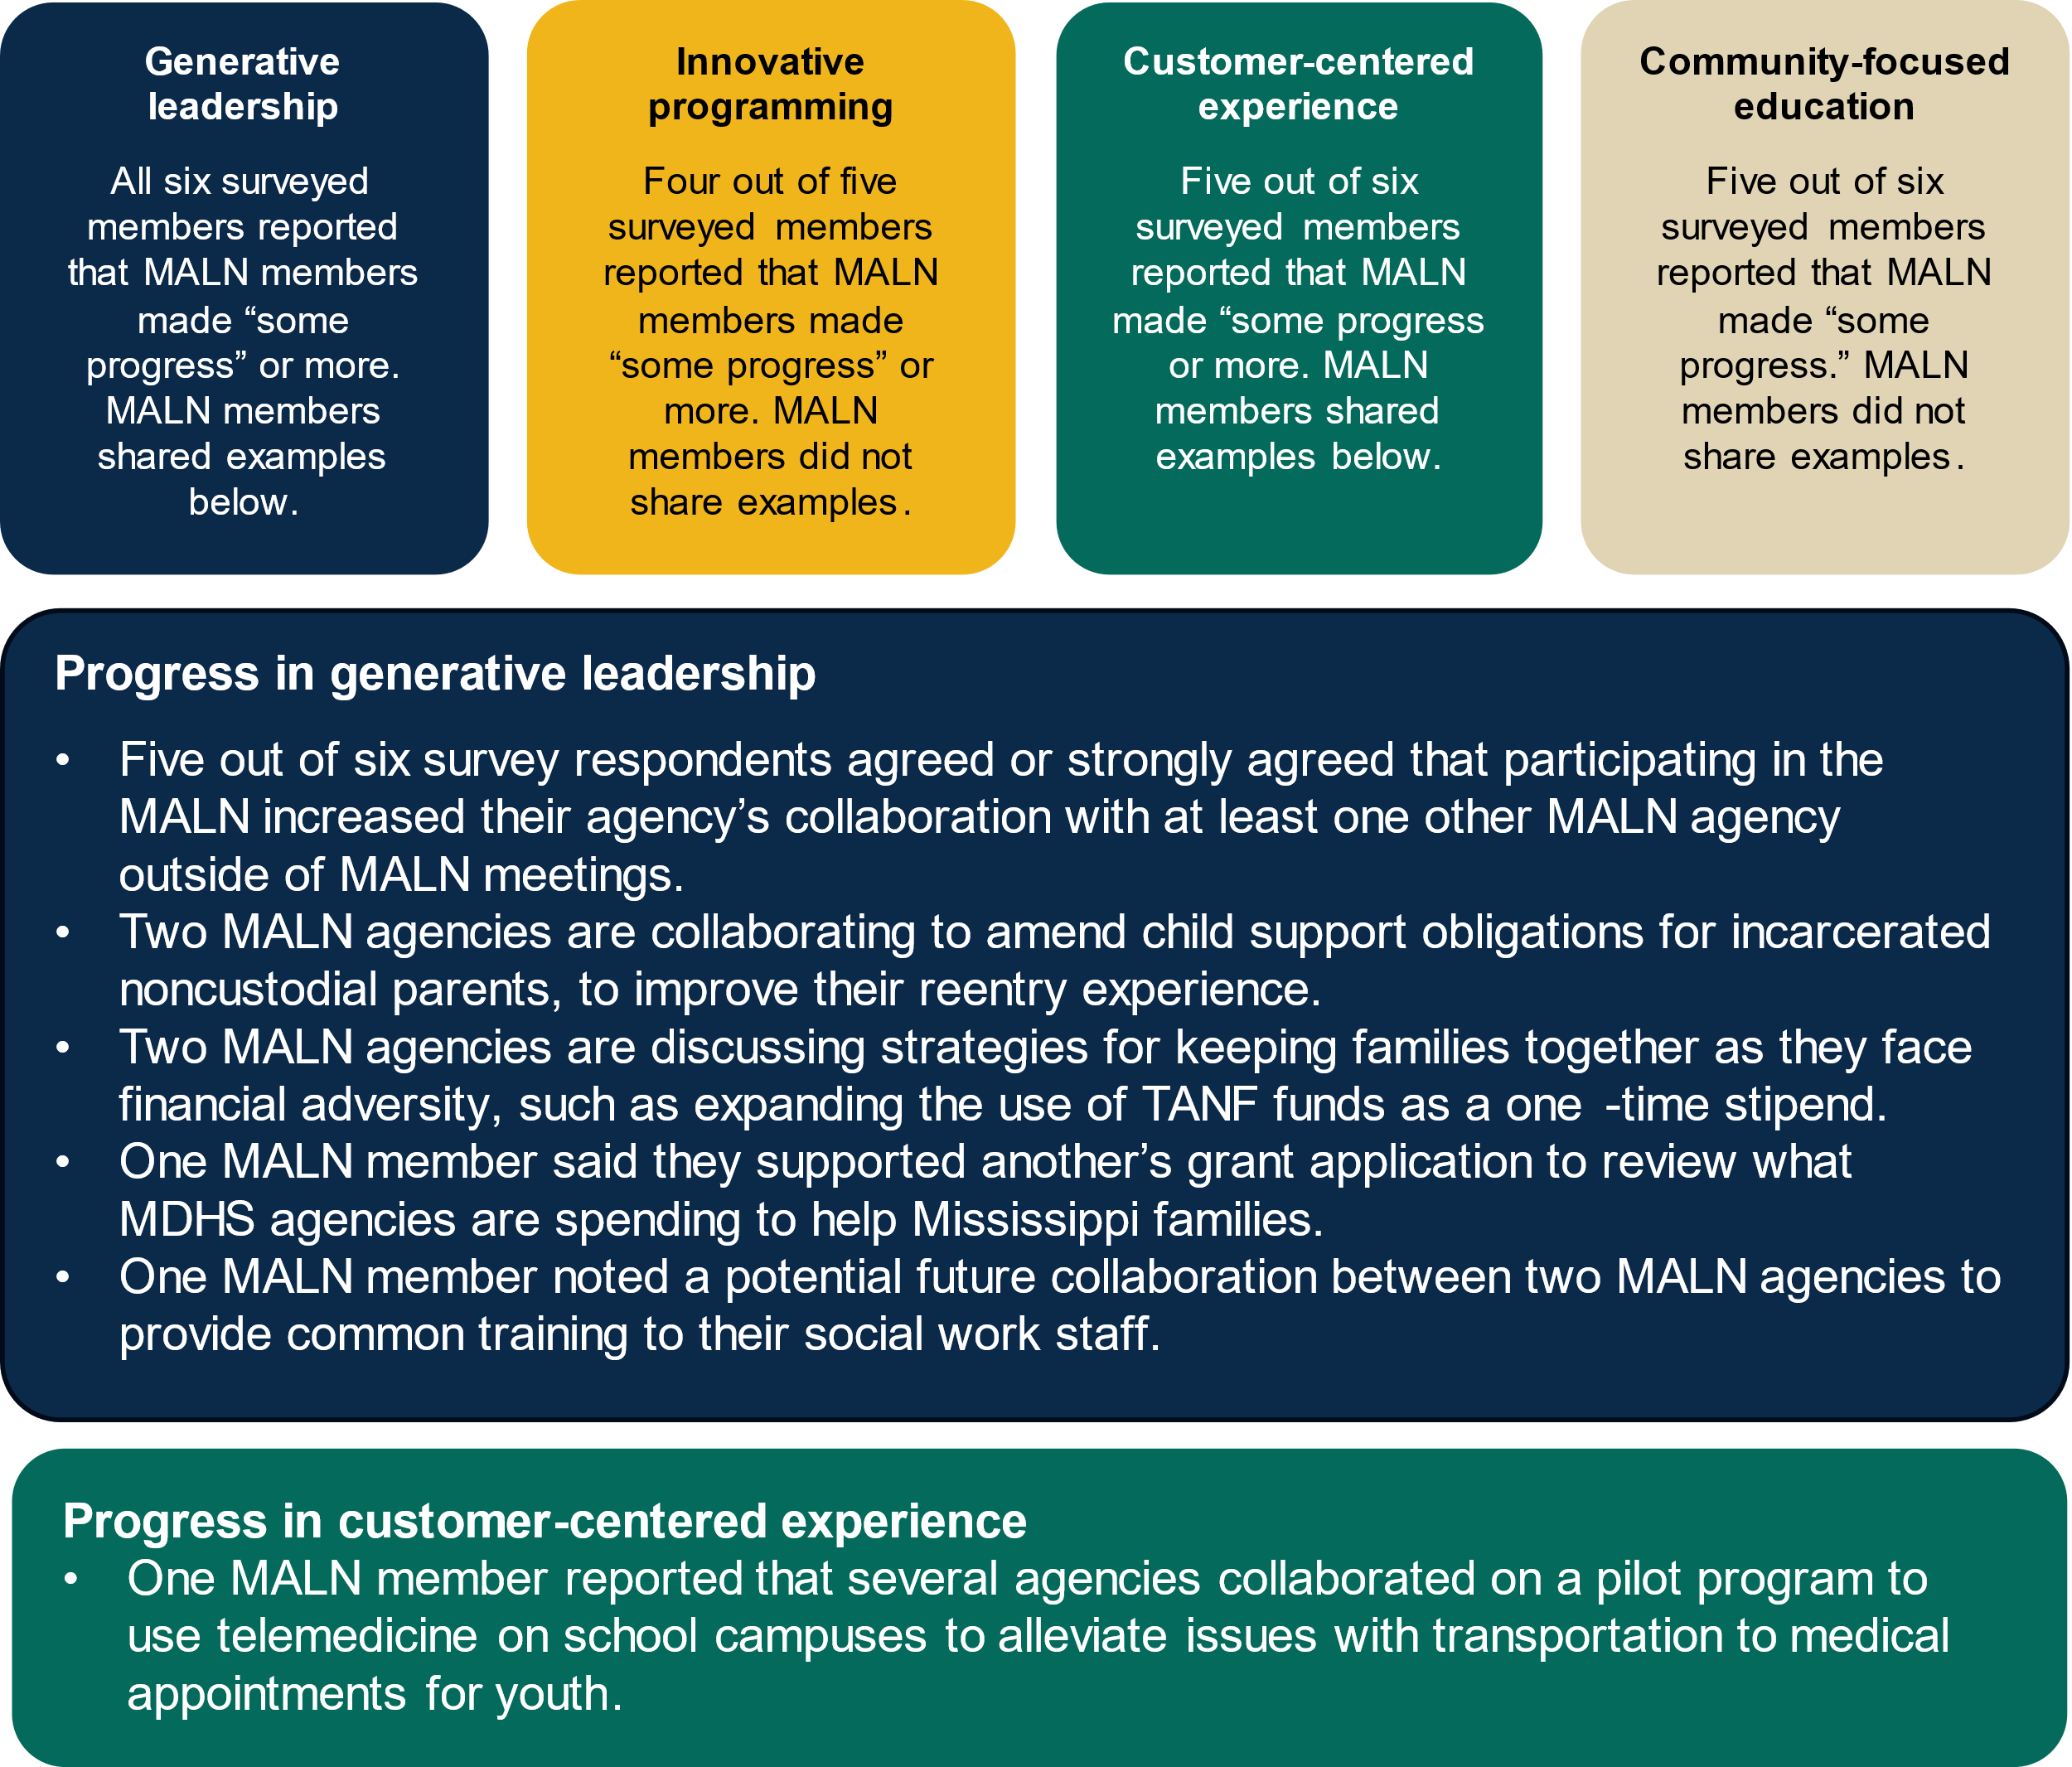

What helped members make progress on the MALN road map?
How did facilitators support members in implementing the road map?
Facilitators noted the importance of MALN members driving implementation of the road map. Facilitators saw their role as helping members develop a space of peer accountability, where members held each other responsible for making progress on the road map. Facilitators said they supported members in sharing and learning and brainstorming action items, but they did not task members with specific items to complete between meetings.
Attending MALN meetings, including creation of and monitoring of the road map. All six survey respondents reported that attending MALN meetings was somewhat or very helpful in making progress on the MALN goals. One interviewed member noted that attending MALN meetings helped leaders build relationships with each other across agencies. This member said that the long-term growth of Mississippi was dependent upon such relationships because agency leaders need to work together. In addition to attending meetings, five out of six survey respondents reported that having a MALN road map with a vision statement and desired future state and monitoring the MALN road map were somewhat or very helpful in making progress on the MALN goals.
Sharing learnings with their staff. Five of six survey respondents reported that sharing learnings with their agency staff was somewhat or very helpful for making progress on the MALN goals. Interviewed members also reported sharing learnings from MALN meetings with their staff. One member who shared some MALN learnings later reported that their staff came up with the idea to provide Uber transportation to health care appointments.
Holding leadership roles. Five of six survey respondents reported that their leadership role within their agency was somewhat or very helpful to making progress on the MALN goals. One member shared that they had the necessary authority to implement a transportation program using TANF funds—something they learned about from a MALN meeting—because of their leadership position in their agency.

What prevented members from making progress on the MALN road map?
Lack of funding for implementation. All six survey respondents reported that not having enough funding made it challenging to make progress on the MALN goals. Interviewed members noted that their agencies had limited funding and that funding requirements often complicated their ability to blend and braid funding. One member shared that federal and state funding often has stringent requirements on its use, which leaves agencies with little room for collaboration. The MALN did not have a dedicated source of funding to support implementation of MALN action items.
Work overload. All six survey respondents reported that not having enough time and capacity made it challenging to make progress on the MALN goals. One member shared that having directors and deputies at the meetings was good to discuss strategy but that often staff below directors, like managers and direct service staff, are the ones who implement the strategy. Facilitators said that because directors often have limited time outside of meetings, they planned to finalize the road map with approval from directors before developing work groups and bringing in other staff to support implementation. A facilitator noted that while they hope the MALN will establish work groups in the future to help with road map implementation, a focus of the MALN has been to first help members develop relationships with each other as state leaders—an important precursor for working together.
“The problem that we’re all going to have is operationalizing anything that we agree on, because we are all tremendously strapped for time and do not have any excess capacity.”
— MALN member

Lack of commitment from other agencies. Five of six survey respondents reported that a lack of commitment from other state agencies in the MALN made it challenging to make progress. MALN members said a lack of consistent representation from all MALN agencies and organizations in meetings prevented them from making progress toward identified priorities and common goals.
MALN members provided the following recommendations for overcoming barriers to progress on the road map:
- Continue meeting and having a regular dialogue.
- Include agency staff below directors in MALN meetings to develop a pipeline of future leaders and to support implementation of the road map.
- Form work groups focused on implementing the road map.
- Pick one main objective for the MALN that is actionable rather than trying to do too much.
- Identify and assign next steps between meetings.

VII. What’s next for the MALN?
Moving forward, MALN members hope to continue meeting and sustaining the work of the MALN on their own. APHSA facilitators said they were in conversations with funders about continuing to support the MALN past June 2024.
Two members said they hoped the MALN would continue to meet regularly on a permanent basis. Members also noted changes that they thought were necessary to sustain the MALN, including having members take ownership of the group and having agency staff support implementation of next steps. One member shared that, although having outside facilitators was helpful, the group must take ownership at some point and do this work themselves.
“The main goal is in essence that we [APHSA facilitators] can walk away and they [MALN members] have designed their own peer learning support system that will continue to function after this learning network is done.”
— MALN facilitator
When asked what advice they would provide to other states on starting learning communities, members and facilitators offered the following recommendations:
- Two members noted that individuals get what they put into the MALN, so they would encourage others to participate in the MALN and be willing to invest their time and energy.
- Another member recommended that members come with an open mind and be willing to have open and honest discussion.
- Another member recommended that learning communities bring in different perspectives and models to move the work forward by inviting private sector and corporate leaders to discussions.
- APHSA facilitators said that flexibility and trust is key to this work.

Methodology
The findings in this brief are based on Mathematica data collection between February 2022 and 2024, including: (1) three focus groups with APHSA facilitators, (2) interviews with four MALN members, (3) MALN member surveys, (4) meeting attendance records, and (5) meeting observations. Mathematica staff conducted focus groups with two APHSA facilitators in March 2022 (baseline), February 2023 (midline), and January 2024 (endline). Mathematica staff conducted interviews with MALN members selected by APHSA facilitators in March 2023 (midline) and February 2024 (endline), for a total of seven interviews with four members who represented four different agencies. Mathematica interviewed three of the same members during both rounds of interviews.
Mathematica sent a systems change survey to 16 MALN members from 10 agencies, between August and September 2023. Four MALN members from three agencies completed the survey. The study team designed the survey based on a framework with discussion questions developed by Mathematica and Equal Measure called the Self-Assessment of Place-Based Systems Change Efforts. The study team modified questions with input from APHSA facilitators to fit the context of the MALN. The study team also sent an endline survey between January and February 2024 to 12 MALN members from 10 agencies. Six MALN members from five agencies completed the survey. Mathematica sent both surveys to a list of MALN members approved by APHSA facilitators, who removed inactive members and agencies.

Acknowledgments
The authors thank APHSA Facilitators Jennifer Kerr and Alex Figueroa for their input on planning the evaluation as well as Brandy Whisman, Christina Becker, and Ann Flagg at APHSA. The authors thank the MALN members. The evaluation would not have been possible without them sharing their feedback on the learning community through interviews, surveys, and allowing Mathematica staff to attend and observe their meetings. Lastly, the authors thank Gina Freeman for data collection support, Aden Bhagwat for note-taking support, Marykate Zukiewicz for project management support, Jon McCay and Matt Stagner for their guidance and quality assurance review, Bridget Gutierrez for editorial support, Sheryl Friedlander for production support, and Jon Owolabi for graphics support.

About Advancing Family and Economic Mobility
Advancing Family and Economic Mobility (AFEM) is an initiative of APHSA that is committed to creating sustainable pathways to economic mobility and well-being for all people and families. The AFEM network fosters new approaches to improving long-term, systemic economic mobility at all levels. To achieve this, AFEM is building a vetted repository of reproducible strategies and resources to share with agencies throughout the United States. For more information, visit www.familyeconomicmobility.com.

In partnership with
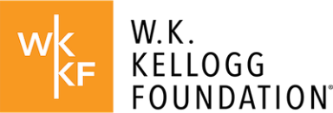
The W.K. Kellogg Foundation, founded in 1930 by breakfast cereal innovator and entrepreneur Will Keith Kellogg, is among the largest philanthropic foundations in the United States. Guided by the belief that all children should have an equal opportunity to thrive, WKKF works with communities to create conditions for vulnerable children to realize their full potential in school, work, and life. WKKF is based in Battle Creek, Michigan, and works throughout the country and internationally as well as with sovereign Tribes. Special attention is paid to areas with high concentrations of poverty where children face significant barriers to success. For more information, visit www.wkkf.org.
Established in 1996, the Doris Duke Foundation (DDF) works to improve the quality of people’s lives through grants supporting the performing arts, environmental conservation, medical research, and child well-being. DDF supports AFEM through its Child Well-being Program, which strives to strengthen and expand the capacity of social service systems that are collaborative and provide culturally appropriate, evidence-based, and context-specific prevention and treatment programs for parents and children. By strengthening the ability of existing social service systems to better serve those in places with sizeable inequities, more children and families can receive the essential supports and resources they need to pursue full, healthy, and happy lives. For more information, visit www.dorisduke.org.

The American Community Survey 2022 1-Year Estimates indicates that the poverty rate for Mississippi is estimated at 19.1 percent, compared to 12.6 percent nationally.
Kania, John, Mark Kramer, and Peter Senge. “The Water of Systems Change.” Boston, MA: FSG, June 2018.

