Issue Brief
Ryan Ruggiero June 2024

Advancing Family Economic Mobility in New England: A Regional Learning Community on Parent Engagement and Leadership
A Whole Family Approach to Jobs: Helping Parents Work and Children Thrive (WFAJ) is an initiative led by the U.S. Department of Health and Human Services’ (HHS) Administration for Children and Families Region 1 Office (ACF), in collaboration with the American Public Human Services Association (APHSA). Launched in 2017, the WFAJ initiative brought together public- and private-sector leaders from six New England states to work toward improving family well-being and economic mobility in their states. Now part of Advancing Family Economic Mobility (AFEM), an initiative committed to “creating sustainable pathways to economic mobility and well-being for all people and families,” the WFAJ connects federal and state New England leaders, including parents, in various ways: (1) an annual convening of state teams, usually held in person, (2) intermittent meetings with six states on emerging areas of interest related to economic mobility, and (3) topical learning communities on subjects of interest to the states, including parent engagement and leadership, racial equity and access, the child tax credit, and the benefits cliff effect.
This brief describes the activities of the WFAJ Parent Engagement and Leadership regional learning community from December 2021 through December 2023. It includes takeaways related to: (1) how the learning community’s leadership team planned and facilitated meetings, (2) meeting attendance, (3) how sharing and learning took place, (4) what participants learned and examples of how they collaborated, and (5) changes participants made to their practices, policies, and programs. Mathematica evaluated this learning community by observing its meetings, conducting separate focus groups with the leadership team and selected learning community participants, and administering a survey to learning community participants. A section on methodology at the end of the brief has more information.

Key takeaways
- Planning and facilitating meetings required the leadership team to have expertise in parent engagement, to align agendas with states’ interests and needs, and to be intentional and interactive in creating agendas. See page 5 for more information.
- An average of 35 participants from multiple sectors attended each meeting, and nearly one-third of all participants attended three or more of the 12 meetings. Participants were motivated to attend meetings because they value learning and sharing with other states and because the federal government participated in meetings. See page 9 for more information.
- Nearly all 24 survey respondents (96 percent) reported that attending learning community meetings deepened their understanding of policy options, best practices, and innovations for engaging parents, including ways to initiate, build, and sustain parent engagement. See page 13 for more information.
- Federal staff who facilitated the learning community shared what they learned with federal staff at the national level, informing components of ACF’s work on lived experience and engaging parents. See page 14 for more information.
- One-quarter of survey respondents said they received technical assistance, available by request, from the leadership team to help change practices, programs, or policies. See page 17 for more information.
- Almost two-thirds of survey respondents (63 percent) reported that they made, are in the process of making, or plan to make practice, program, or policy changes related to engaging parents. Examples include developing a family advocacy council, providing parent stipends, and passing the Child Tax Credit. See page 19 for more information.

I. What is the Parent Engagement and Leadership Learning Community?
The New England regional Parent Engagement and Leadership Learning Community is a topical learning community within the WFAJ initiative. The learning community is facilitated by a leadership team made up of the ACF regional administrator for Region 1, an ACF regional program specialist, and a state co-lead. The leadership team described the learning community as a peer-to-peer partnership where state leaders across different sectors share and learn best practices, innovations, and solutions with each other related to parent engagement in state work. A member of the leadership team defined parent engagement as “including parent insights and recommendations from parents’ lived experience” to inform culture, practice, program, and policy decisions. The purpose of the learning community is to help cross-sector leaders in six New England states learn the ingredients to start, maintain, and succeed in embedding parent voice and leadership in their state’s practices, programs, and policies. The ultimate goal is to improve outcomes for children and families in New England states.
Key planned activities of the learning community include: (1) the leadership team plans and facilitates meetings; (2) participants attend and share best practices, innovations, and solutions with each other; and (3) the leadership team offers technical assistance to states outside of meetings to help participants apply and adapt what they learn to their agency or state context. As described in Figure 1, the leadership team believes that by engaging in these activities, cross-sector leaders will determine what steps to take in their states to embed consumer voice within their programs, practices, and policies.
Figure 1. Theory of change
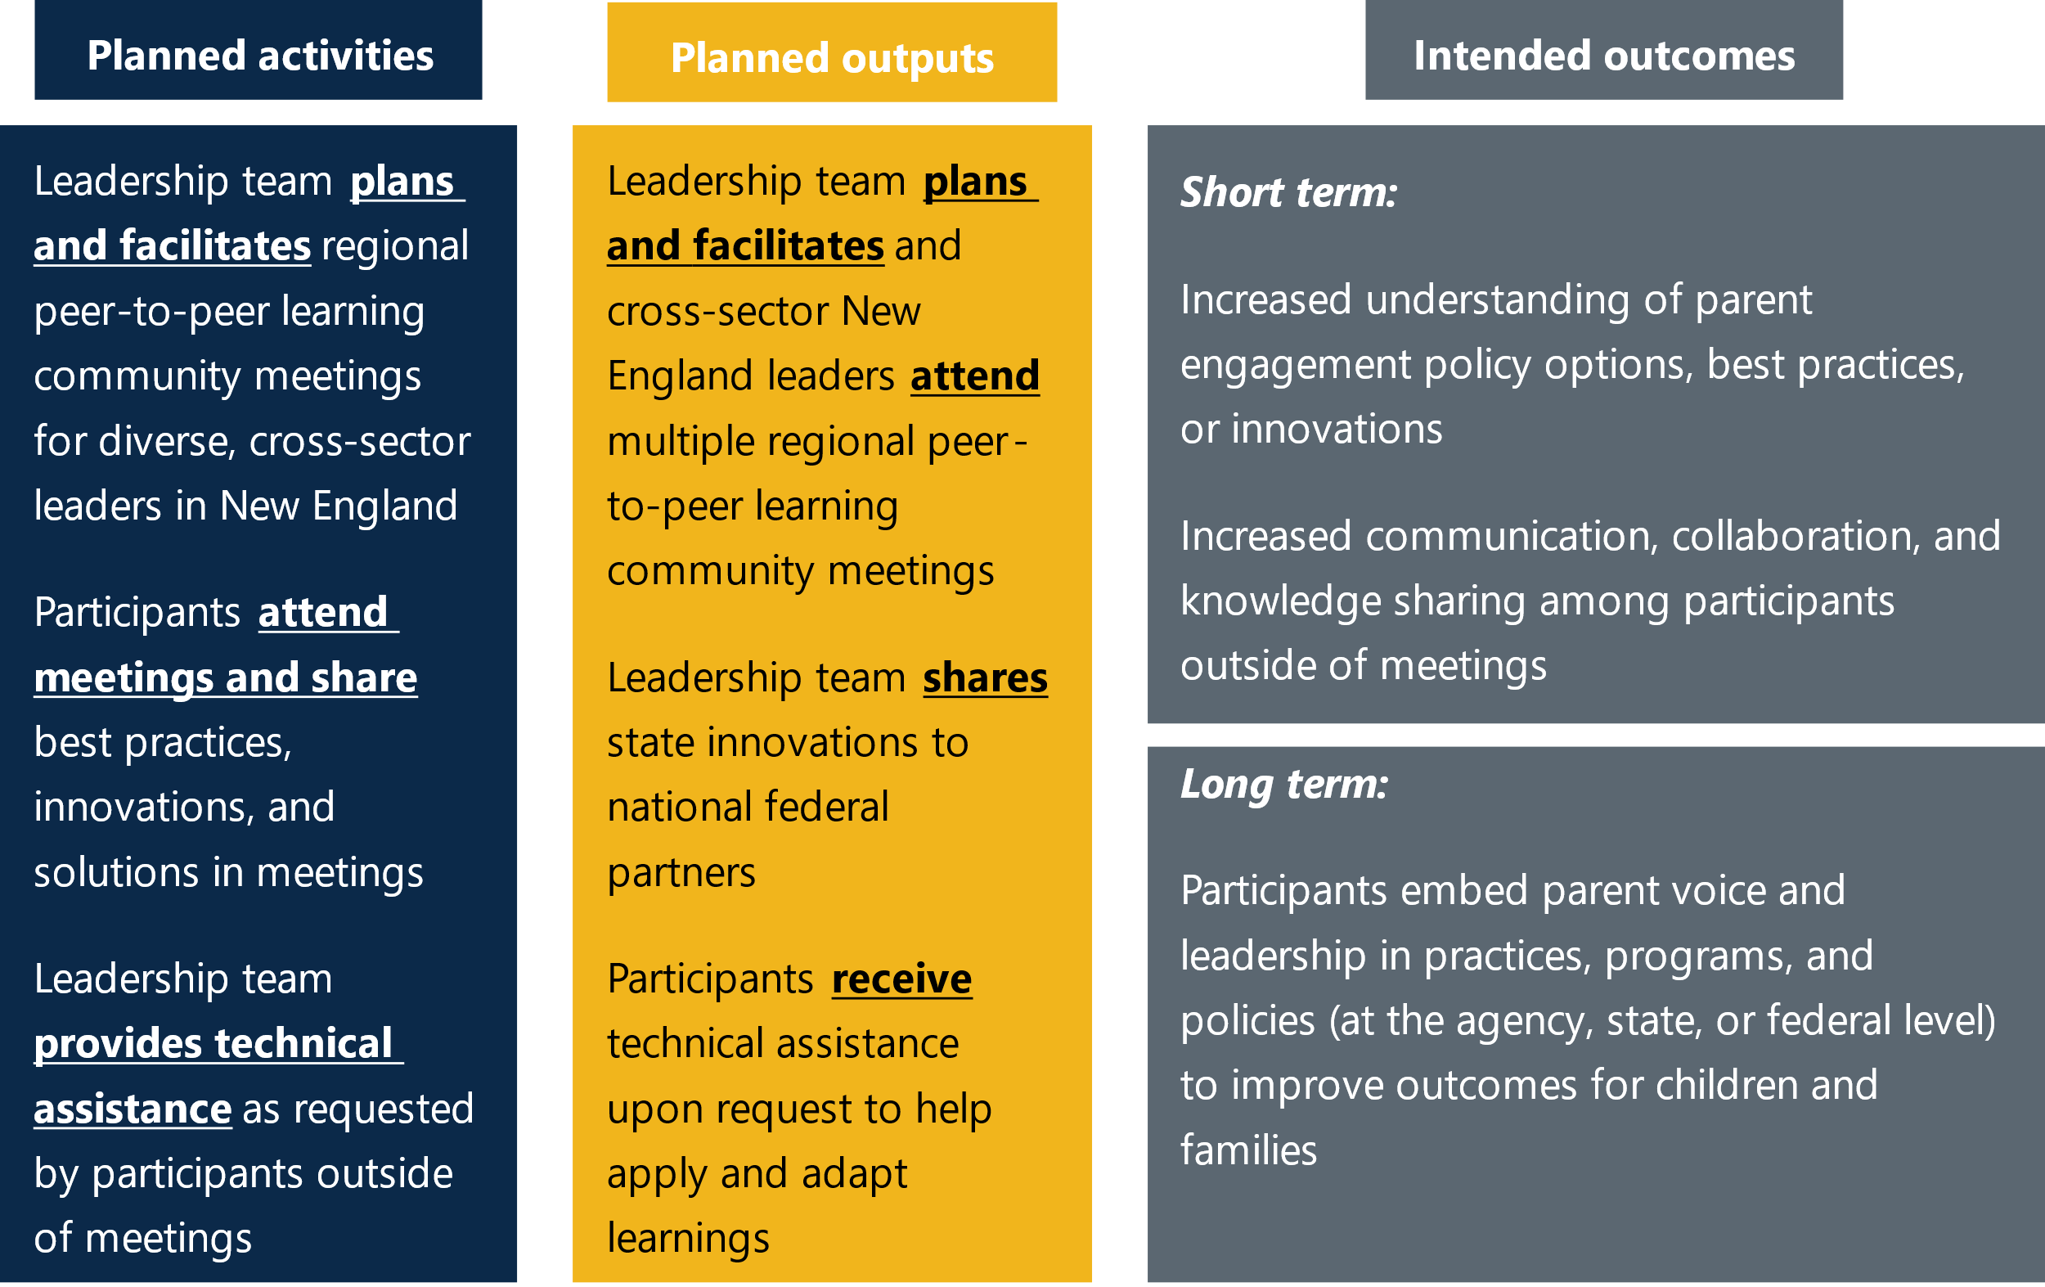

“This was one of the best experiences I’ve had with an ACF regional office. I hope to see similar learning communities across all the regions!”  — Learning community participant | “The bigger question for the learning community is, ‘How do we bring consumer voice into state and federal government and community work?’”  — Leadership team member

How was the learning community started?
The mission of ACF’s regional offices is to advise the ACF assistant secretary about state relations and cross-cutting, results-based strategic initiatives. The goal is to leverage public-private partnerships to improve outcomes for children and families. The leaders of the WFAJ initiative, two ACF staff and a consultant, launched the learning community in December 2021. Before the learning community met for the first time, leaders of the WFAJ initiative conducted several activities to inform creation of the topical learning community, including:
“Unlike many things, you decided you need to eat more vegetables, so you’re going to make vegetable soup. There are all these recipes for vegetable soup, but there’s not a whole lot of recipes on parent engagement.”
— Leadership team member

- Hosting a panel on parent engagement as part of the broader WFAJ initiative. At that panel, they observed that New England state human service agencies were interested in parent engagement.
- Administering a survey to New England state human service agencies to learn more about their interests. The survey confirmed that state agencies wanted to learn about promising practices and structures for parent engagement, strategies for sustaining family engagement, and policy levers. The leaders of the WFAJ initiative said many state agencies saw opportunities to improve their work during the COVID-19 pandemic so it was more customer focused, informed directly by those they serve.
Changing the human services systems within New England states
The regional learning community brings together human services state leaders across New England. A leadership team member said that state leaders determined what actions their state teams may take outside of learning community meetings to improve their state human services system. The leadership team said that before the COVID-19 pandemic, six New England state teams, with state leads, were part of the WFAJ structure to advance economic mobility within states. The leadership team said state leaders were overextended and exhausted during the pandemic due to managing a public health crisis and changing demands in service provision, making some state teams inactive or less active.
Although state teams were not the focus of Mathematica’s evaluation of the regional learning community, Mathematica facilitated virtual discussions in 2023 with two active New England state teams. The two teams were chosen by the leadership team, and the discussions were held to examine each state team’s strengths and areas for improvement related to factors likely to help their partnership achieve systems change.
What is systems change? Systems change initiatives aim to shift the conditions that hold a problem in place by changing policies, practices, resource flows, relationships and connections, power dynamics, and mental models (deeply held beliefs and thoughts).
Key takeaways from systems change assessments with two state teams
- During the virtual discussions with each state team, members indicated that their partnership showed readiness for systems change, identifying areas of strength and room for growth.
- Both state teams were strongest in multisector collaboration and alignment to support targeted outcomes and goals, and in sustainable resources and infrastructure. Both teams agreed that their partnership “fully” has: (1) structures and processes to facilitate active and genuine partner engagement, and (2) committed, diverse, and sustained funding. For example, one state team said their work with parents has a structure, with regular meetings and committed state and philanthropic funding.
- Both state teams zeroed in on similar areas for growth: data infrastructure; trust and accountability; and equity in vision, mission, and action. Both teams thought they “somewhat” had: (1) an equity statement or goal, and (2) a concrete plan to improve outcomes; that (3) partners “somewhat” trust and hold each other accountable for implementing activities, and (4) there are “some” established norms and systems for data collection, management, and reporting across partners. For example, one state team believed they could do more to track and evaluate outcomes of their partnership, and another state identified an opportunity to have a comprehensive strategy with accountability measures for partners.
- Conducting interviews during the pandemic to learn how state leaders wanted the WFAJ work to continue. State leaders raised parent engagement again as a topic of interest.

II. How did the leadership team plan and facilitate meetings?
From December 2021 through December 2023, the leadership team planned and facilitated 12 virtual learning community meetings on Zoom. The leadership team members said they met regularly to create agendas together, taking time to think about meeting topics independently before sharing ideas with each other in planning meetings. To prepare agendas, the leadership team sometimes consulted others, including parents, about a specific topic. Members of the leadership team facilitated varied discussion formats—such as panels, large groups, and breakouts—but it was common for invited speakers or selected participants to also facilitate discussions. Each meeting typically began with a welcome and kickoff from the ACF regional administrator. In addition to their planning and facilitation role, members of the leadership team took notes during meetings and sent invitees meeting notes, audio recordings, attachments, and links to resources that were shared and discussed during meetings.
How did partners support the WFAJ initiative?
Since its inception in 2017, WFAJ collaborated with a national organization acting as a strategic partner. WFAJ first partnered with the National Conference of State Legislatures and now partners with APHSA. APHSA supported the WFAJ’s annual convenings, provided technical and communications assistance, and compensated parent leaders who participated. The W.K. Kellogg Foundation and the Doris Duke Charitable Foundation funded the WFAJ initiative, along with local philanthropies, and assumed the costs of venue rental space, transportation, and food for the WFAJ 2024 in-person annual convening. Parents who participated in the WFAJ annual convening also received compensation, including travel and child care expenses. Members of the leadership team participated in the initiative as part of their regular work duties.
The following takeaways describe how the leadership team planned the meetings and their recommendations for how to promote sharing and learning during meetings:
Be a trusted expert on parent engagement or consult experts. Members of the leadership team said they were trusted to lead discussions on the topic because of their expertise in parent engagement. The ACF regional administrator has more than 30 years of experience engaging parents. Before joining ACF, she developed a training for parents on leadership for the Connecticut Commission on Children and co-led efforts to build a coalition of state and city parent engagement groups across the country. The state co-lead is the associate director of parent leadership and family engagement for Connecticut’s General Assembly and worked for almost a decade as a consultant with the National Parent Leadership Institute. Both bring to the learning community their vast experience working directly with parents in Connecticut to inform state policy. A member of the leadership team said that if a facilitator is not an expert in parent engagement, it is important to collaborate with an expert when planning and facilitating meetings.
Be intentional and iterative in creating meeting agendas. The leadership team emphasized the need to be thoughtful when planning meeting agendas, describing meetings as “an art form, not a checklist.” They often spent several hours planning each meeting and said they structured meetings in a way that created a sense of community, where participants were open to learning new ideas. Every meeting included time for discussion so participants could provide their thoughts and ask questions. At times, the leadership team repeated topics to reinforce concepts. The leadership team said they intentionally chose “deep, not superficial content areas” to help state agencies understand how to influence parent engagement on the state level. They sought to inform and improve agendas by debriefing with each other after each meeting to reflect on what worked well and what could be changed in the future.
“Parent engagement is new for people, and they don’t know how to do it. It’s a little bit like learning a foreign language. You have to repeat it and repeat it and repeat it, and you have to practice it; you get ‘ahas’ at different points.”
— Leadership team member
Align meeting agendas with states’ interests and needs related to parent engagement. The leadership team reported that understanding the needs of states, including the state context, is important when creating meeting agendas of interest to multiple states. The leadership team strategically drafted agendas to consider states’ needs and how state leaders may influence parent engagement within their agencies and state. One leadership team member knew what states were doing related to parent engagement (and other topics) because she had ongoing conversations with New England state human services agencies in her role as the regional administrator. The state co-lead worked on parent engagement activities in her state every day, which informed her role on the leadership team. These experiences contributed to developing meeting agendas, in addition to the leadership team regularly asking for feedback from participants in meetings.
It was common for the leadership team, before ending meetings, to ask participants to type in the Zoom chat something they learned in the meeting or additional questions they had. The leadership team also listened closely to the questions participants asked in meetings, and they used Mathematica’s findings from the learning checkpoint to inform future meeting topics. The term “learning checkpoint” refers to activities Mathematica conducted twice during learning community meetings to collect and assess feedback from participants.
“There’s an intentional thinking through of all the different pieces that have to be learned and asking, if one wanted to influence parent engagement on the state level, what would one need to know, and then how would one scaffold that?”
— Leadership team member
Have cohesiveness in the leadership team and bring joy to the work. The leadership team members had a history of working together before starting the learning community. Two of them worked closely together for several years in Connecticut to advance family-centered policies. Two worked closely together at ACF, both as part of WFAJ and in their regional work outside of the initiative. All three members of the leadership team worked closely together concurrently on another learning community focused on the child tax credit, which gave them ample opportunities to work together in addition to their parent engagement work. One leadership team member said that because of their history working together, they knew how to collaborate and were able to plan meetings more efficiently. Another member said they all have deep joy in the parent engagement work, which is an asset when planning meetings.
Use meetings as an opportunity to model parent engagement. The leadership team members emphasized that it was important for them to show, not just tell, participants how to engage parents in state work. According to attendance records, parent leaders regularly attended learning community meetings. A leadership team member said that parent leaders are parents who are already working with state or nonprofit organization staff, and parent leaders were invited by state staff to attend learning community meetings. The leadership team said some parent leaders participated in
“You cannot talk about lived experience without having people with lived experience in the room.”
— Leadership team member
planning some meetings. The leadership team frequently met with parent leaders before meetings to give them the full context of a meeting, explain their role in the meeting, and give parents the opportunity to inform the agenda. The leadership team also included parent leaders on panels during meetings to share their experiences, and parent leaders both facilitated discussions and asked and answered questions. APHSA paid parent leaders who participated in learning community panels $50 per hour, which included time to prepare for their presentations. Parent leaders who attended learning community meetings were not paid. As shown in Figure 2, surveyed parent leaders agreed that they participated in planning a meeting agenda or in a panel, that meetings allowed them to share their experiences, and that their perspective was valued during meetings.
Figure 2. Parent leaders’ survey responses
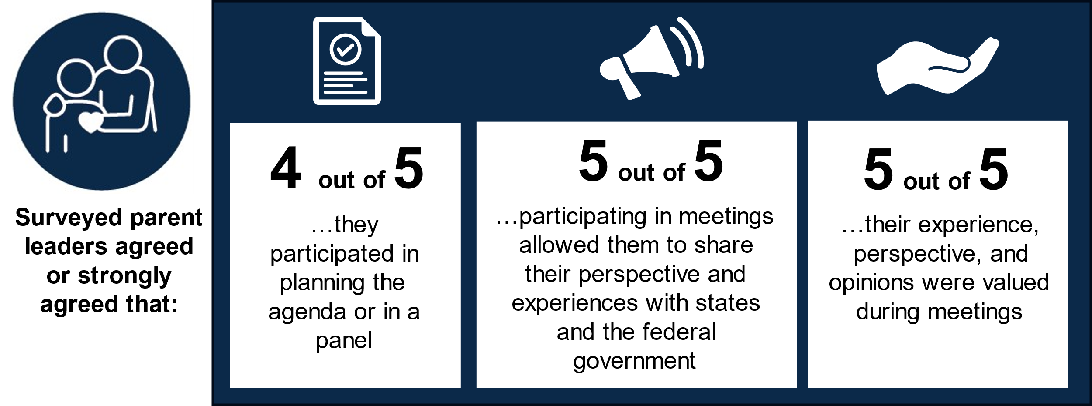

III. Who attended learning community meetings?
The learning community included a subset of WFAJ participants. The leadership team members said they wanted a large group of cross-sector state leaders to attend the meetings, and they invited more than 100 WFAJ leaders from all New England states to learning community meetings. The leadership team used the term “leaders” broadly to describe New England state agency staff and staff from non-state agencies, including nonprofit and philanthropic organizations. From December 2021 to December 2023, an estimated 176 participants attended at least one learning community meeting, with an average of 35 participants in each meeting (including guest speakers and the leadership team). In the first year, the leadership team facilitated eight virtual meetings, and in the second year they facilitated four virtual meetings, allowing participants to dive deeper into specific topics. The leadership team sent advance notice of all meetings at the start of 2023 and required advance registration by participants in the second year to better track participation.
Multiple sectors were represented at meetings, but more than half of meeting participants were from a state agency. Attendance records show that meeting participants represented various sectors including human services staff, parent leaders, federal staff, and staff from philanthropic organizations and nonprofit organizations. However, other state agency staff also attended meetings from areas including child support, early childhood, transitional assistance, Temporary Assistance for Needy Families, and policy and management. Of the 118 meeting participants for whom data were available, more than half (56 percent) were from a state agency, 22 percent from a federal agency, and 11 percent were parent leaders. Types of state agency participants included state commissioners, policy directors, and program managers. The leadership team members were satisfied with the diversity of meeting participants, referring to the different sectors represented in meetings over the two years.
Examples of represented organizations and agencies that attended at least one learning community meeting
- Massachusetts Department of Transitional Assistance
- Connecticut Office of Policy and Management
- Rhode Island Department of Health and Human Services
- Vermont Department for Children and Families
- Parent Leadership Training Institute
- Southern New Hampshire Services
- Reach UP Vermont
- O’Neil Foundation
- New Hampshire Department of Health and Human Services
- Maine Department of Health and Human Services
- Administration for Children and Families
Nearly one-third of meeting participants attended three or more meetings, and at least one parent leader attended every meeting. Attendance records show that of the 176 participants over the two years and 12 meetings, about 31 percent (54 participants) attended three or more meetings, and 69 percent (122 participants) attended one or two meetings. The leadership team did not plan to have the same people attend every meeting, but one member had hoped there would be a core group of meeting participants who attended multiple meetings. A leadership team member said meeting invitations were open to state agency staff at various levels, and it was unrealistic to expect state leaders to attend every meeting. However, they also said that going forward, they intend to consider how to more intentionally bring state government leaders into the learning community. Overall, the leadership team was satisfied with the number and mix of participants in each meeting.
Participants included state agency staff outside of New England. Although the learning community’s focus is New England, four state agency staff outside of New England attended meetings. State agency staff from 10 states—all six New England states and Pennsylvania, Michigan, Ohio, and New York—also participated in meetings. A leadership team member said the states outside of New England found out about learning community meetings from the ACF regional administrator’s work training child support directors outside of New England; state agency staff from these states were interested in attending learning community meetings to learn more about how to engage parents in their child support work.
Figure 3. Types of participants and their attendance rates
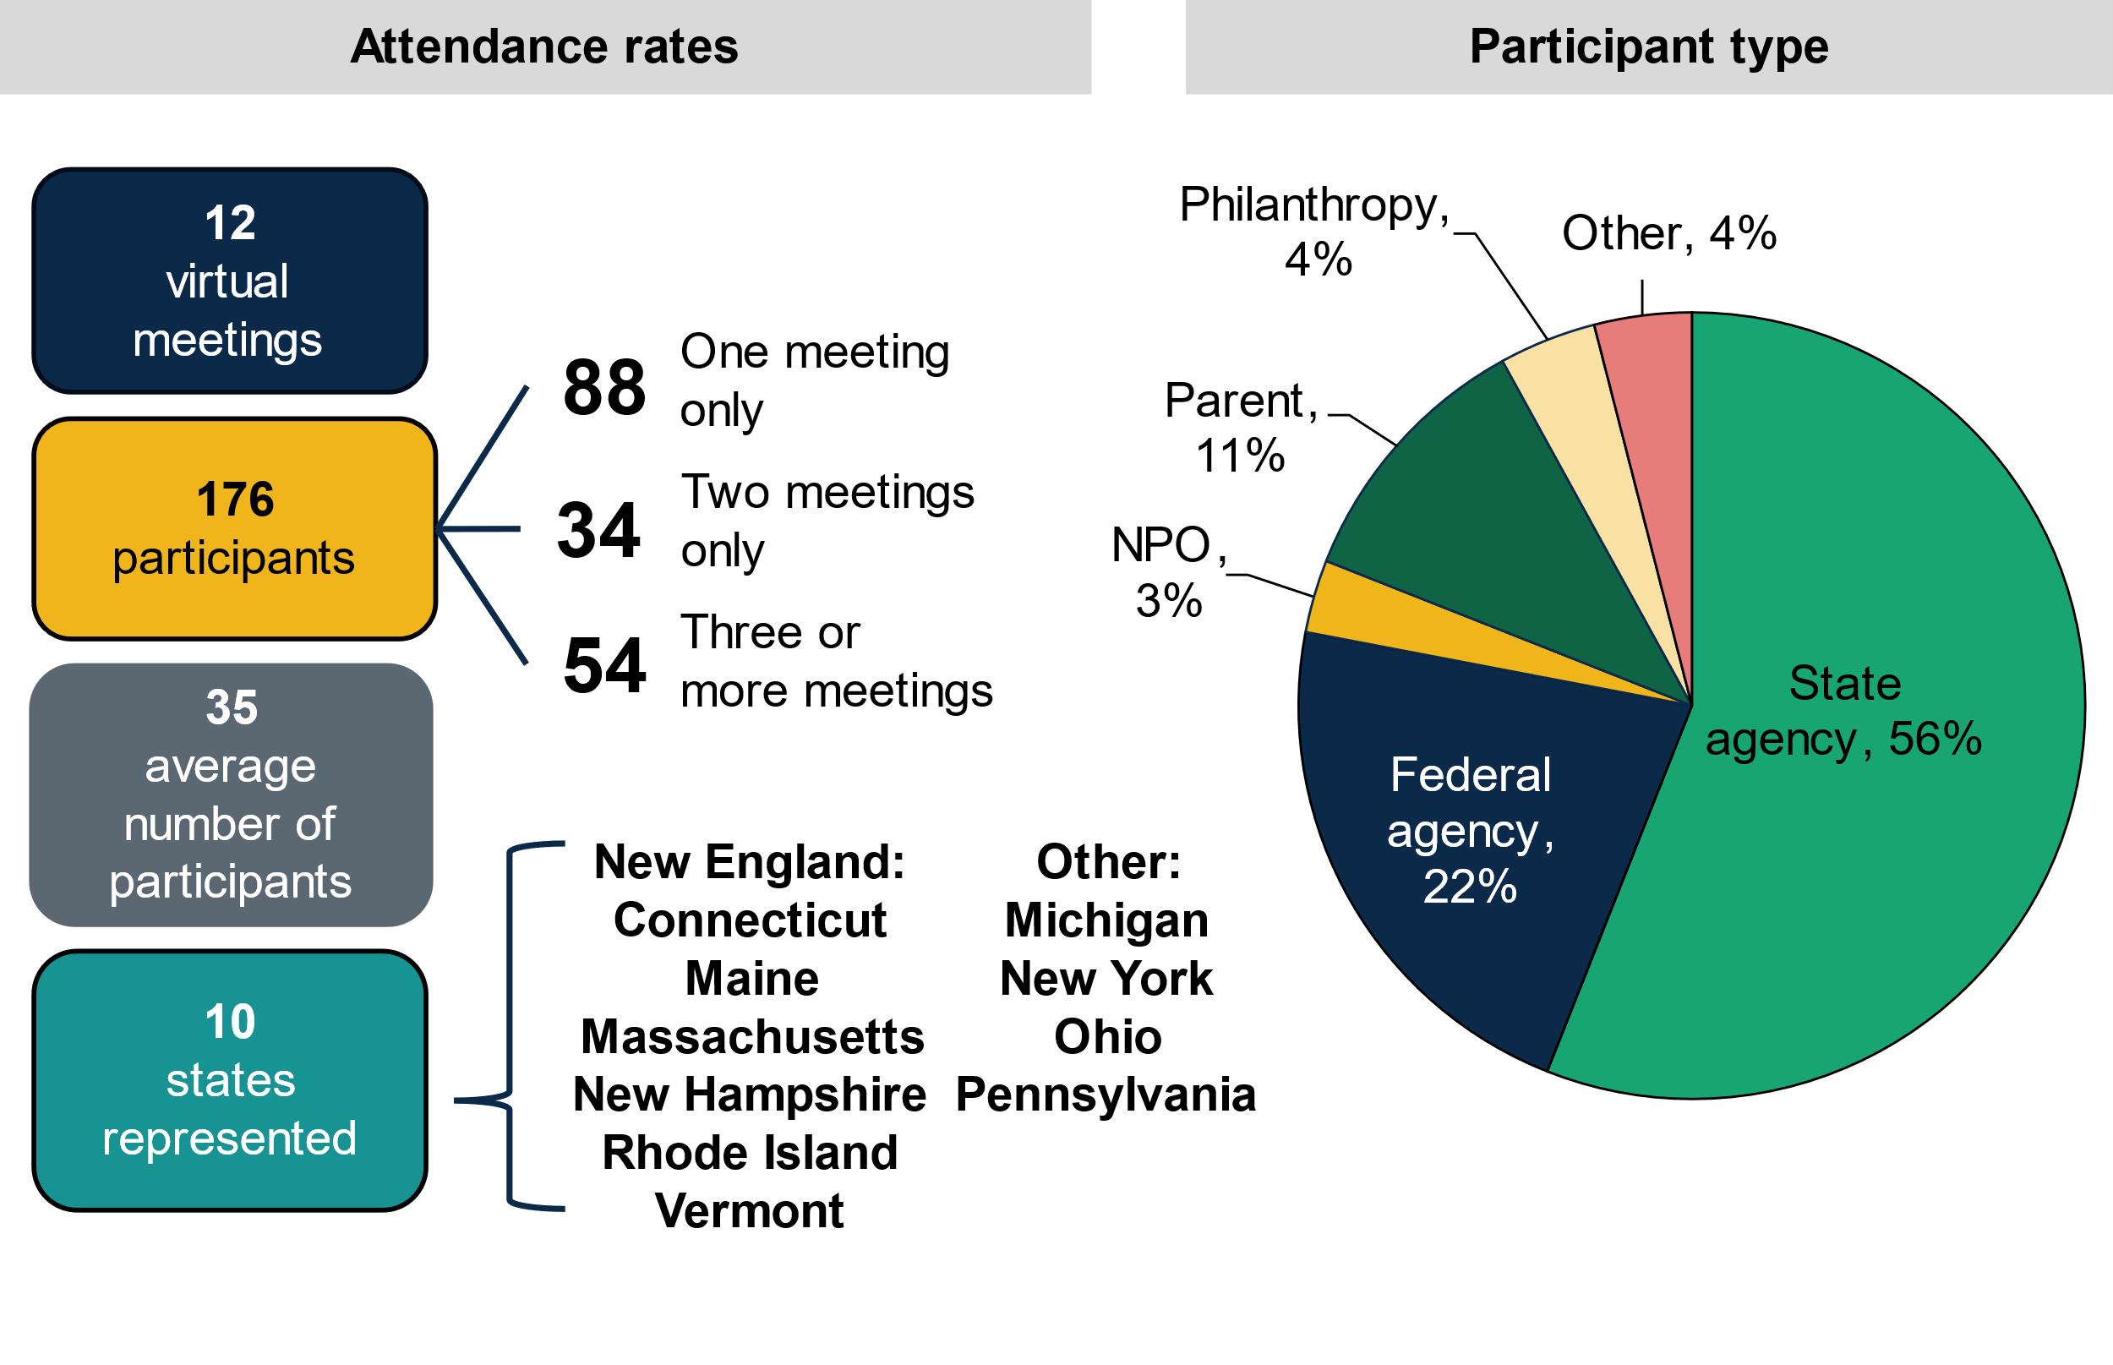
Note: Attendance records reflect meeting attendance between December 2021 and December 2023 and includes leadership team members. NPO stands for nonprofit organization.
Competing priorities made it difficult for the leadership team to plan and for participants to attend meetings. The leadership team members said they regularly juggled multiple work priorities in their other federal and state roles, which sometimes made it challenging to find the time they needed to plan learning community meetings. The leadership team members said both they and state agencies faced competing priorities in their roles because parent engagement is one of many topics that are important to ACF and states. The team emphasized the effect of the COVID-19 pandemic on both federal and state government workload and priorities. They also said that during the pandemic, government staff were exhausted from managing a public health crisis that took their full attention. At the same time, they pointed out there is a worker shortage in state government, making it difficult for state leaders to consistently attend meetings. Learning community focus group participants similarly said they sometimes missed meetings because an urgent matter came up. They noted that, although parent engagement work is important, there is no one holding them accountable to attend meetings.
“The country is in post-COVID times with a new work structure that no one has settled into, a worker shortage, and growing demands. It is a time of old and new ways with limited workers and people adjusting.”
— Leadership team member

Participants suggested ways to overcome meeting attendance challenges:
- Ask another colleague to attend,
- Send meeting agendas in advance, and
- Schedule meetings in advance.
Participants said having the agenda and the topics in advance helped them either prioritize attending the meeting themselves or sending someone else on their behalf, and that plenty of meeting notice is also helpful. One participant said, “With the agendas going out early enough, you’re able to make the time for such an important meeting.”

What motivated participants to attend meetings?
In focus groups, learning community participants discussed what motivated them to attend learning community meetings.
Participants value learning best practices from and problem solving with other states and parents. Focus group participants said learning best practices from other states was a main driver for attending meetings because it gave participants ideas for how to engage parents and how to address challenges they faced in engaging parents. They also enjoyed sharing their experiences and informing the work of both other states and the federal government. One participant said their motivation for attending meetings was to listen and learn and bring what they learned back to their organization. Another said learning about the practices of other states allowed them to consider ways to adapt practices to their state’s context. One survey respondent noted that listening to parents describe leadership opportunities they had in their state helped them reevaluate their own agency’s strategy for engaging parents.
“I love to learn from different states. I get ideas for how I can potentially make changes in my community.”  — Learning community participant | “At the end, the goal is the same—it’s to break intergenerational poverty…I say ‘steal with zeal’: If there’s something that is working in Vermont that we think might work here, well, let’s do that. If Connecticut has something, we might tweak it.”  — Learning community participant
The federal government’s presence in meetings demonstrated its commitment to partnering with states. Focus group participants credited the federal government’s leadership and presence in learning community meetings as a motivating factor for attending the meetings. Participants said there has been a shift in government the past few years toward thinking about how to engage people with lived experience in designing and delivering services to families. They said hearing the federal government discuss how to engage parents and coordinate the initiative made the work more credible because the federal government is following through on the approach, “Nothing about us, without us.” Participants said gaining the attention of the federal government in meetings has been a “game changer,” because they can share barriers they face directly with federal staff, especially barriers the state cannot control or change, and the federal government staff frequently offered helpful guidance or directions. For example, one participant shared a barrier their federally funded agency faced with the leadership team during a meeting. This participant said they informed ACF that their state agency cannot provide gas money to help clients in the Special Supplemental Program for Women, Infants, and Children (WIC) due to federal policy. All federal staff who attended meetings were from ACF, with the exception of two federal staff from the Substance Abuse and Mental Health Services Administration.
“Knowing that they [federal government] are at the table and can effect that change when they figure out what the barrier is, that’s a game changer.”
— Learning community participant

Meetings are inspirational. Focus group participants said they left meetings feeling inspired by facilitators and the work other states are doing, and this motivated them to attend future meetings. Participants said the ACF regional administrator’s passion and expertise in parent engagement has been a motivating factor, noting, “She is so eloquent in this topic.” One participant said learning about the different ways parent engagement work is implemented excites them.
Participants have a personal and organizational interest in parent engagement. Focus group participants said both their personal and organizational interest in learning more about how to effectively engage parents also motivated them to attend learning community meetings. Several participants worked on parent engagement initiatives before joining the learning community. One participant talked about how attending meetings helped educate them on how to engage parents beyond what they were already doing on several state initiatives. The leadership team noted that President Biden’s leadership message on rebuilding trust in government and focus on bringing in the customer elevated the topic of parent engagement (or lived experience) around the country. They said states seemed more willing to have discussions about how to engage parents in their work. The leadership team highlighted an immediacy on the part of states to help people understand how to do this work, and parents were more willing to share their voices as they felt valued in this space.

IV. How did sharing and learning happen during meetings?
Learning community meetings gave participants a space to share and learn best practices, innovations, and solutions with each other in real time. Each meeting was typically 90 minutes long, and meetings regularly included panels with parent leaders, large and small group discussions facilitated by the leadership team, guest speakers, and questions to attendees about what they learned or questions on a given topic. Facilitators often shared information about what ACF was working on related to parent engagement and how it tied into the work of states. Examples of agenda topics included how to partner with families; readiness for parent engagement and leadership; parent engagement strategy, tactics, and innovation; evaluation; and federal and state strategies for compensating parents.
Most participants in the learning community focus groups said they were satisfied with the amount of sharing and learning during meetings, noting that the content was well thought out, and the information shared about programs and initiatives was insightful. Participants also said that resources shared after meetings helped inform their work, especially when “you have limited time to try to launch something,” or when they were unable to attend a meeting. They thought there were a few challenges to sharing and learning during meetings, including wanting more time for individual states to talk to each other to help with specific advice or strategies, and cited the challenges of virtual meetings. They thought virtual meetings were convenient and potentially allowed more people to attend meetings, but in-person meetings could promote stronger personal connections and have fewer distractions. Another participant recommended that facilitators broaden the context of shared examples to help them better apply examples to their own work, and recommended including parents from New England states other than Connecticut.

What helped participants share and learn during meetings?
In focus groups, learning community participants discussed what helped them share and learn during learning community meetings.
The meetings had both small-group breakout sessions and time for large-group peer sharing. Focus group participants said the leadership team structured meetings in a way that promoted sharing and learning, and included content that was relevant to their work. Participants thought breakout sessions with a smaller group allowed for in-depth conversations, peer sharing, and time to solve specific issues directly with other state agencies. One participant said they liked that the meeting structure allowed time for discussion and was consistent in every meeting. Some survey respondents would have liked even more meeting time to discuss strategies and ask for advice from parents and other states.
“I love[d] knowing that the format is always going to allow time for best practices and then discussing what we’ve learned.”
- Learning community participant

Parent leaders shared their perspective and experiences. Focus group participants believed hearing directly from parent leaders helped them learn effective ways to engage parents and allowed them to get feedback from parents on proposed strategies. Participants said they typically do not have many chances to hear directly from parents, and one participant said that hearing from parents is one of the best parts of the learning community. A leadership team member said they were satisfied with the way parents participated in meetings. All five surveyed parent leaders agreed or strongly agreed that participating in meetings allowed them to share their perspective and experiences with states and the federal government.
“One of the greatest parts of this community is hearing from parents. We [states] often talk to each other, but hearing from parents puts it in a great perspective.”
— Learning community member

Facilitators created a safe and welcoming meeting culture. Focus group participants described the meeting culture as “not intimidating” and “informal,” which helped them open up and share. Participants said the facilitators were positive and made them feel good no matter what they shared during meetings. The leadership team also said it is important for facilitation to be relaxed “without being formless,” allowing for enough time to teach content and for peer sharing; and to focus on “adult learning principles” because participants have varied levels of experience with engaging parents. One participant said participants were comfortable with each other because of work they did together in the WFAJ initiative that preceded this learning community.

V. What did participants learn during meetings?
A desired short-term outcome of the learning community is that by attending meetings, participants will deepen their understanding of policy options, best practices, or innovations related to parent engagement. Mathematica sent an endline survey to learning community participants in January 2024—not including the leadership team—to understand what they learned during meetings. Twenty-four participants from five New England states and three non-New England states responded to the survey. As shown in Figure 4, nearly all of the 24 (96 percent) learning community participants who responded to the survey agreed or strongly agreed that participating in the learning community increased their understanding of policy options, best practices, or innovations related to parent engagement.
“One of the key learnings was that organizations who want to do this work really need to put in the time and be intentional about helping parents feel comfortable, prepared, and equipped to contribute when they are asked to come to the table … often as a funder, people want to see concrete, immediate results, and when you’re talking about building relationships and trust—that takes time.”
— Learning community participant
Figure 4. Knowledge gained about engaging parents
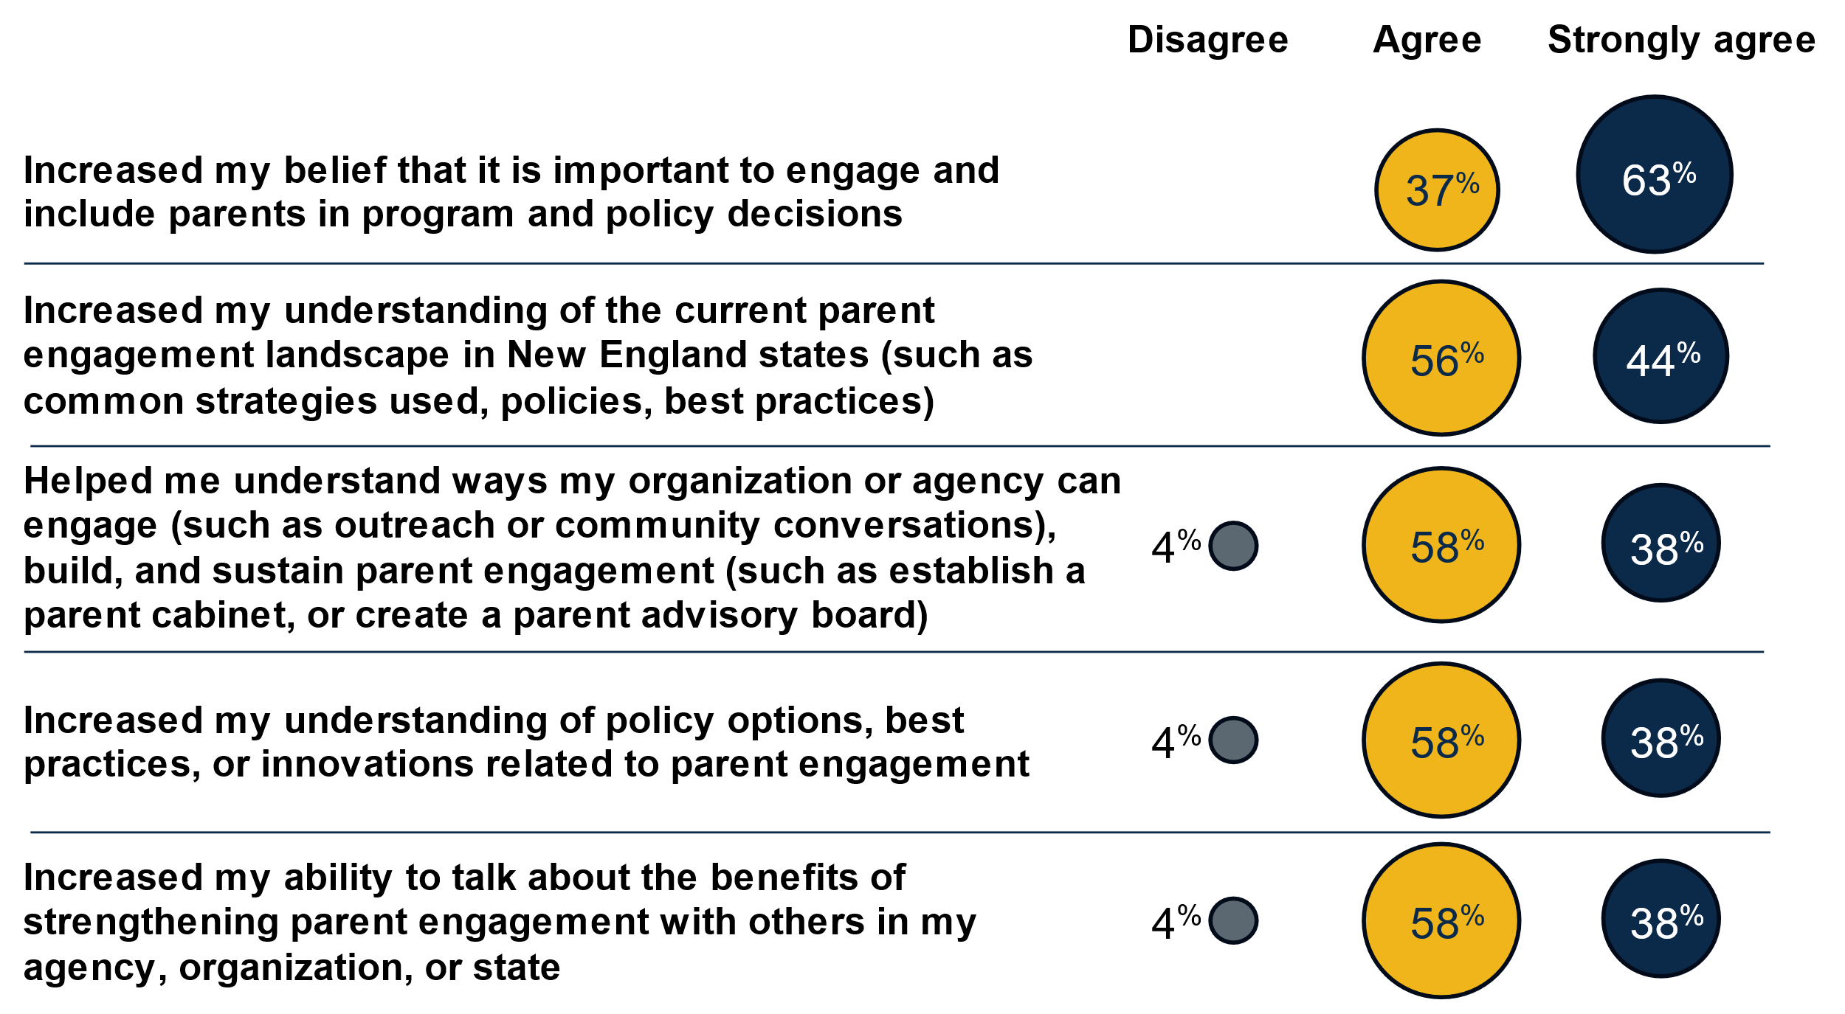
Note: The n for each survey question is 24 except for the second question, where n = 23.
Nearly all survey respondents (96 percent) agreed or strongly agreed that participating helped them understand ways to engage parents and build and sustain parent engagement efforts. Examples of engaging parents in state agencies or organizations include outreach or community conversations with parents, and examples of sustaining parent engagement include establishing a parent cabinet or creating a parent advisory board. Survey respondents gave examples of what they learned to promote parent engagement within their organizations or agencies, such as compensating parents for their time to show that agencies value parents and view them as experts. Respondents learned the importance of doing pre-work to help parents feel confident participating in purposeful ways, which often requires training staff on family-centered practices and building trust with parents. They also appreciated insights on how to establish parent councils within their agency, which was different from how they thought they should set up the council. One survey respondent said, “Hearing about the specific details of how to start the parent council was practical and helpful.”
All survey respondents agreed or strongly agreed that participating increased their belief that it is important to engage and include parents in policy decisions. Survey respondents said that by participating in the learning community, they learned how important lived experience is to informing the work of their agencies. They also learned that giving parents opportunities to participate in conversations about community change generated insight they otherwise would not have had without engaging parents in these conversations. One survey respondent said the meetings confirmed their existing beliefs about engaging parents.
All survey respondents agreed or strongly agreed that participation increased their understanding of the current parent engagement landscape in New England states. Learning community focus group participants agreed that it was helpful to hear examples from other states about how they are using strategies and connections to build their programs with parent input. One participant learned what Connecticut was doing with the Parent Leadership Training Institute to train parents. Another participant said that during a learning community meeting they learned from parent experiences shared by an organization in Massachusetts. One parent appreciated learning more about what states are doing to engage parents, knowing that states are working toward involving parents more.
“We don’t have to learn anything as parent representatives. They need to be open to it and willing to engage and do things differently.”  — Parent leader | “The experience of learning from other parents from other states has helped with advocating on challenging issues that felt hopeless. I love seeing how parents across New England are coming together to share and break down barriers to better service us all.”  — Parent leader
Parent leaders learned from each other during meetings. Surveyed parents said that, in addition to feeling valued in learning community meetings, they appreciated attending meetings where other parent leaders were in attendance to add to the conversation. One parent leader said involving parents in meetings allowed for the exchange of ideas that helped parents consider what to suggest in their own state and could help parents advocate on issues. Another enjoyed learning how other parents became involved in the parent engagement work in their state and what the requirements to participate were. Although most of the parent feedback was positive, one surveyed parent would have liked an opportunity to present on a topic they worked on before the learning community meetings.
The bi-directional learning that took place between the federal government and state participants informed ACF’s work on lived experience and parent engagement. Most survey respondents (92 percent) reported that participating in the learning community deepened their understanding of the current parent engagement landscape within the federal government, such as common strategies, policies, and best practices. Similarly, the leadership team, composed mostly of regional ACF staff, said that facilitating and attending learning community meetings allowed them to learn from states and parents. The leadership team learned from participants that some state leaders lacked a sense of urgency about parent engagement work; that some states could bring together state agencies and parents more effectively than others, and that some participants incorrectly thought that creating an excellent parent engagement process meant giving up power.
The regional administrator described her role as “a bridge to Washington,” and said she often shared what she learned from states with ACF staff in the national office, both informally and formally. She also said she shared learnings at trainings with other ACF regional leaders, with federal staff, in reports to ACF staff in the national office, in meetings with ACF leadership, and by embedding learnings into the WFAJ work. For example, the leadership team shared notes with other regional ACF colleagues in nine geographic areas about what they learned from state agencies on how to compensate parents. The regional administrator said lessons from the parent engagement learning community and Mathematica’s midline evaluation findings informed components of her role as consultant on ACF’s Advisory Committee on Strategy to Embed Lived Experience in ACF Culture, Policy, and Practice, which is designed to train ACF staff on how to embed lived experience into programs, policy, and culture.
The leadership team said what they learned from state participants also informed their own work. For example, they dove deeper into practicing effective parent engagement themselves by having parents open the in-person 2024 WFAJ annual meeting, and they included parents throughout by having parents lead a major exercise on the first day and including parents in every panel. The leadership team described a “feedback loop,” as shown in Figure 5, in which they shared insights from Washington with learning community participants and shared what they learned from participants back with Washington.
Figure 5. The federal-to-state feedback loop  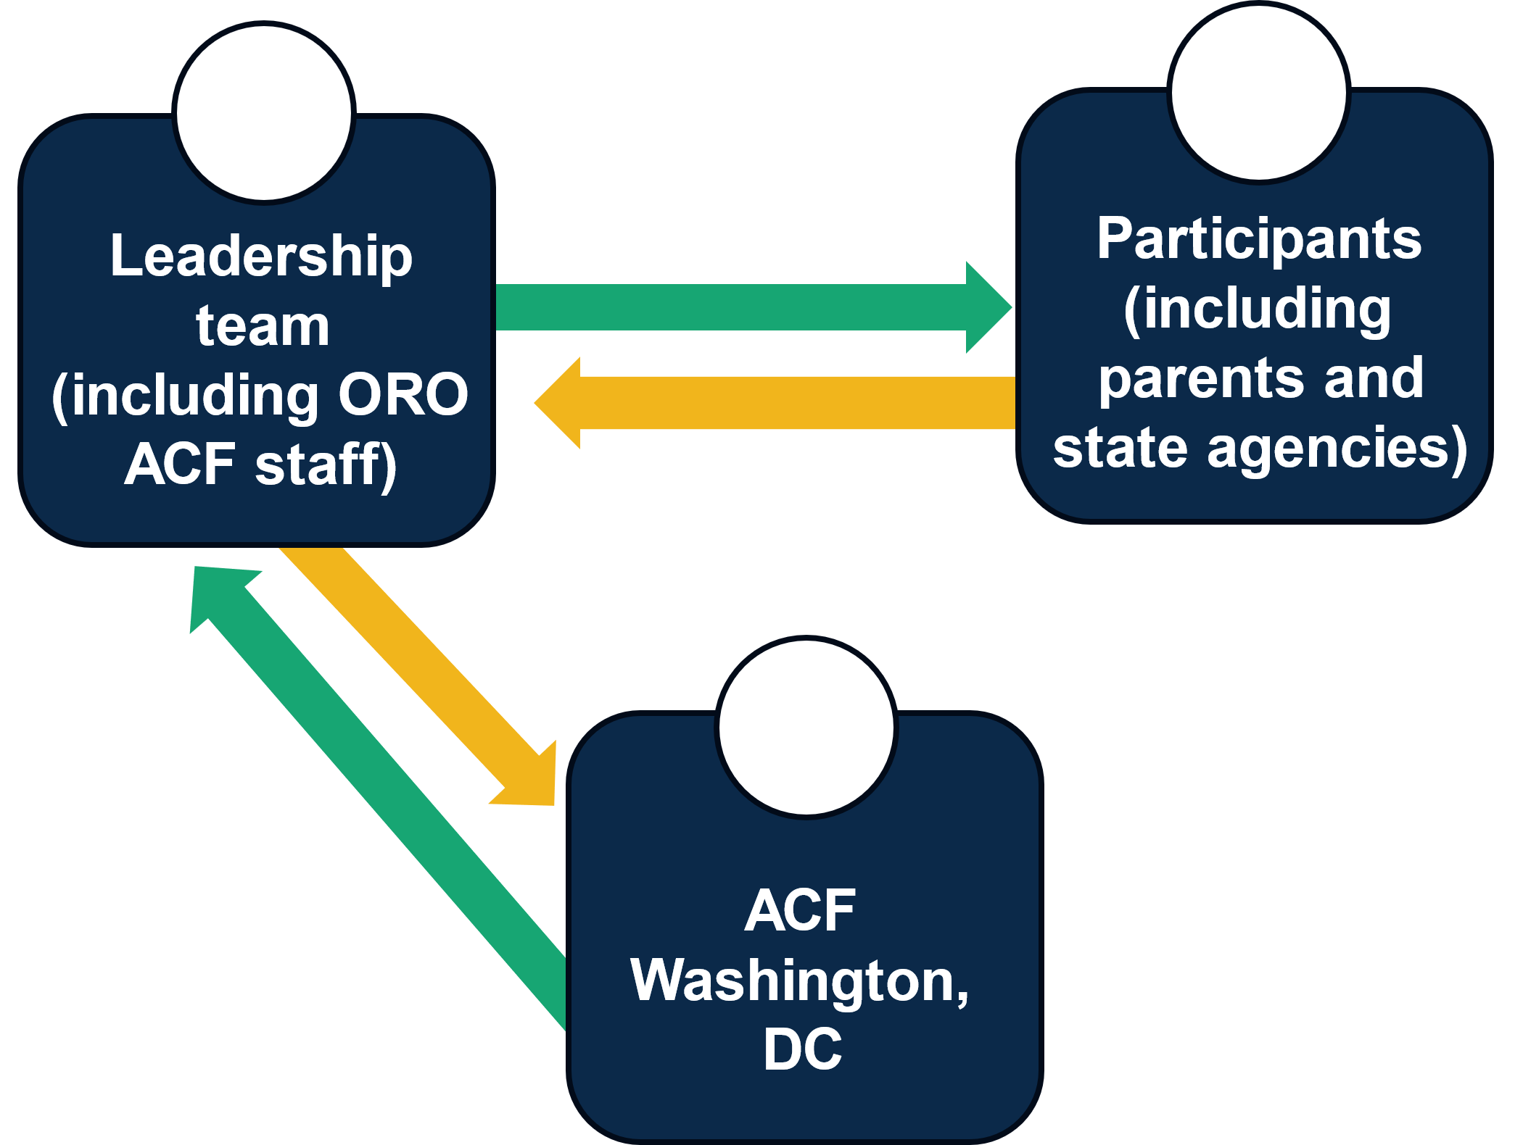 | “We are linking among the states, listening to the states, and bringing key insights to Washington, and hopefully creating communications where something is improved because that’s the whole point.”  — Leadership team member

Learning checkpoints to advance continuous learning and improvement
Twice during the evaluation (September 2022 and September 2023), Mathematica conducted learning checkpoints to promote action-oriented and timely opportunities for the leadership team and participants to improve the learning community. Mathematica led each checkpoint during learning community meetings, collected feedback from participants through MURAL, analyzed the feedback, and shared findings with the leadership team in a separate follow-up discussion. Participants noted the following strengths and growth opportunities for the learning community at these checkpoints:
- Areas of strength. Participants are satisfied with the amount of sharing and learning taking place during meetings, the meeting structure and frequency, and parent involvement in meetings. Participants want to keep meeting, and they value opportunities for conversations with other participants during meetings.
- Areas of growth. Participants recommended that the leadership team clarify who can be invited to meetings, improve resource sharing outside of meetings, and engage parents in planning meetings. Participants would like more opportunities for parents to lead meetings and more tools on how to get leadership buy-in on parent engagement.
In addition to learning checkpoints, Mathematica conducted and shared midline evaluation findings in spring 2023 with the leadership team and learning community members. The leadership team said they used these findings to inform subsequent learning community meetings.

VI. How did participants collaborate with each other outside of meetings?
A desired short-term outcome of the learning community is that by attending meetings, participants will communicate, collaborate, and share knowledge with each other more often outside of meetings. Survey responses indicated that participants did strengthen their relationships, and that collaboration outside of meetings was happening, with some room for improvement.
Participants reported stronger relationships with other New England states, parents, and federal partners. Survey respondents agreed or strongly agreed that participating in the learning community strengthened their relationships with other New England states (78 percent), parents (75 percent), and federal agencies (69 percent). One learning community focus group participant said meetings allowed them to build relationships with other participants, making it easier to talk to participants at the annual meeting or to reach out to states outside of meetings.
“I would not hesitate to pick up the phone [and call someone] who just presented and say, ‘Okay, explain this to me.’ We just have that sort of community; it is a pretty tight-knit community.”
— Learning community participant
Figure 6. Survey respondents reported that participation increased collaboration with each other outside of meetings in various ways
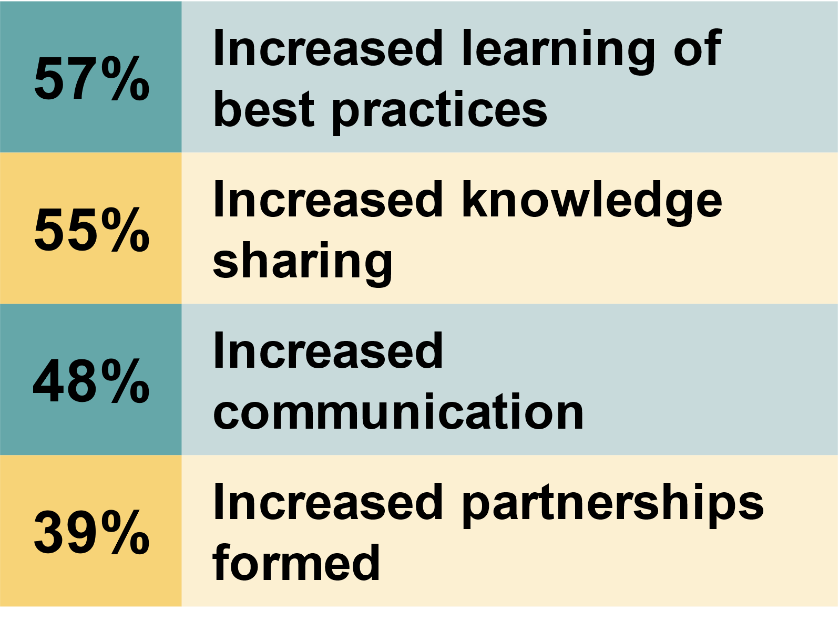
Note: The n for each survey question ranges from
18 to 21.
Participants reported more collaboration related to parent engagement outside of meetings with parents, other New England states, and federal agencies. Survey respondents agreed or strongly agreed that participating in the learning community increased collaboration with parents (72 percent), community agencies that include parents (67 percent), other New England states (64 percent), and federal agencies (61 percent). The survey defined collaboration as “knowledge sharing, learning, or partnering with others toward change, such as by producing an effect or product to advance economic mobility related to parent engagement.” Survey respondents reported the most collaboration was in learning best practices from each other outside of meetings, followed by knowledge sharing. One focus group participant said ACF facilitates connections between states outside of meetings by connecting states that are working on similar projects. As shown in Figure 6, survey respondents agreed or strongly agreed that participation increased their collaboration on parent engagement with at least one other New England state outside of learning community meetings through increased learning of best practices, knowledge sharing, communication, and partnerships.
The leadership team said child support agencies outside of Region 1 invited the ACF regional administrator to train their staff on how to incorporate lived experience into their work. The ACF regional administrator said she also met with the Tribal Early Learning Initiative Project (TELI), a group of early childhood tribal leaders, to “consider how to bring in parents into their co-planning and design efforts.” A focus group participant who represented a philanthropic organization said the ACF regional administrator attended their grantee meeting and shared knowledge about effective parent engagement and how to operationalize parent engagement. Grantees were from New York City, Washington, DC, Cleveland, Baltimore, and Hawaii. The participant said, “her [regional administrator’s] presentation was very well received, and she followed up by sharing resources on evaluating parent engagement practices.”

VII. What type of technical assistance did participants receive?
To help change practice, programs, and policies related to engaging parents in state work, the leadership team planned to provide technical assistance outside of meetings by participant request. During the first year of the learning community, the leadership team said they did not offer technical assistance to participants because the focus was on discussing parent engagement and laying the groundwork for the learning community. In the second year, however, the leadership team members offered technical assistance to states that wanted to embed parent engagement into a component of their work, such as an initiative, program, or policy. State agency staff were notified of the technical assistance opportunity at the start of 2023, and states could email the leadership team for technical assistance if they were interested. Learning community focus group participants said more practical tools and resources could help advance their parent engagement work; the leadership team members are drafting resources to support participants’ work on parent compensation and agency readiness to engage parents.
“What’s important to me is knowing they’re [leadership team] available and willing to take our call. That’s a big deal to us, to know that I can just send a quick email or get on a call, and they’ll connect me to somebody that could help if they can. That gives you the confidence to do the work.”  — Learning community participant | “Maybe the more state agencies learn about high quality sustainable parent engagement, there is a tendency to feel it is an overwhelming task that is untenable given the other priorities they must lead on.”  — Leadership team member
The leadership team shared examples of technical assistance they provided to participants:
- Met with state agency leaders to help the agency determine strategies to incorporate parent engagement
- Worked with young parents and a state agency to establish young parent councils across the state
- Helped one state get insights from parents to inform the state’s parent engagement toolkit and training
More than half of survey respondents (54 percent) did not receive technical assistance to change practices, programs, or policies related to parent engagement. Twenty-five percent of survey respondents said their agency or state received technical assistance, and 21 percent said, “I’m not sure.” The leadership team said they provided technical assistance to states that requested their support. They said human services leaders may not have the time they need to pursue or request technical assistance because the parent engagement work requires sustained leadership and resources from agencies and organizations. One focus group participant agreed, saying one obstacle to requesting technical assistance was that their agency was not in a place where it was ready to benefit from the support.
Participants who received technical assistance said it helped them change their parent engagement practices, programs, or policies. Of the 11 survey respondents who received technical assistance, all of them said it was somewhat or very helpful in changing their practices, programs, or policies. Focus group participants noted that at least one of the leadership team members was available to answer their questions and offer support and guidance outside of meetings. One survey respondent said support from a leadership team member outside of meetings helped them brainstorm how to train parents, noting that the technical assistance “really made a difference in the approach that we took and how it played out.” The leadership team members said they were able to provide technical assistance directly to state agencies because two of their members are viewed as leaders in parent engagement, and they developed relationships with participating state agencies, which also helped. Still, the leadership team noted that it was at times challenging for them to provide technical assistance to participants because it often required them to work extra hours each week.

VIII. What changes did participants make at their agency, organization, or state level?
The intended long-term outcome of the learning community is that participants embed parent voice and leadership into practice, programs, and policies to improve outcomes for children and families. The leadership team noted that participants brought different experiences and expertise to the parent engagement work, and likewise some participants said their agencies were already working on ways to engage parents before they attended learning community meetings. Although it can take several years to achieve long-term outcomes, learning community participants shared examples of changes they made to advance parent engagement within their agencies or states.
Almost two-thirds (63 percent) of survey respondents reported that their organization, agency, or state made, is in the process of making, or plans to make practice, program, or policy changes. One-third (33 percent) of survey respondents reported that they made a change; 17 percent are working on a change; and 13 percent plan to make a change related to something they learned from the learning community.
- All survey respondents said that attending learning community meetings and using what they learned was somewhat or very helpful in changing practices, programs, or policies.
- All survey respondents reported that hearing outside speakers, collaborating with parents or agencies that include parents, and collaborating with other states was somewhat or very helpful.
- All survey respondents also said parent engagement was a policy priority for their organization, agency, or state, and consequently was a somewhat helpful or very helpful factor in making change, as was support on parent engagement from agency leadership.
Some participants were already engaging parents before attending learning community meetings, but what they learned in the meetings informed their work. A survey respondent said that before joining the learning community, their agency was in the process of creating an advisory council with parents for a grant they received. They said they plan to incorporate lessons from the learning community into this council. Another survey respondent said they engaged parents as partners to advance economic mobility before joining the learning community. Likewise, they said the learning community reinforced this and inspired their organization to continue implementing best practices to engage parents as partners. Another participant said they shared information with their funder, noting that effectively engaging parents takes time.
“I can’t really say that the learning community helped [my organization] make changes … it solidified what we are currently doing and has affirmed that we are moving in the right direction.”
— Learning community participant
Participants shared examples of practice, program, or policy changes their organization, agency, or state made based on something they learned in the learning community:
- Policy change. One state passed the Child Tax Credit, which will take effect in 2025 and provide income directly to families.
- Policy change. After hearing about challenges families face with child care costs, one state offered more funding to child care (sliding scale) and increased funding to families who receive or apply for subsidies (Care4kids).
- Practice change. One participant said that instead of giving parents gift cards to a specific store, their agency now provides stipends to parents, noting, “We have seen how that stipend has allowed a parent to be in attendance … since they do not feel like participation is harming their household. The stipend says, ‘We trust you with your financial decisions.’”
- Practice change. After learning what Connecticut was doing with the National Parent Training Institute, one state agency partnered with the institute with support from a leadership team member. The agency changed its approach and had a community college partner host the parent training.
- Practice change. One participant said their agency hosted meetings on specific topics to get more information directly from parents about their experiences.
- Program change. One participant said their agency developed a family advocacy council.
- Planned changes. Participants intend to incorporate more feedback from parents into their program; prioritize client-centered information in their organization’s learning and impact framework; create a parent cabinet in their state with the voices of those most impacted in front of policymakers; and start a fatherhood advisory board.
One-quarter of survey respondents reported that their organization, agency, or state had not made any practice, program, or policy changes. Survey respondents reported that the top barriers to making practice, program, or policy changes related to parent engagement included work overload (91 percent), difficulty changing organizational culture (85 percent), not having access to funding to implement what they learned (80 percent) or not having access to funded technical assistance (75 percent). The leadership team noted that inconsistent meeting attendance by participants, likely related to competing work priorities as noted, may have affected agency implementation of what they learned from the learning community.
Survey respondents provided recommendations for how participants can overcome barriers to change parent engagement practices, programs, and policies:
- Connect state leaders with frontline workers who directly serve parents so frontline workers can implement lessons from parent engagement at the local level.
- Pursue organizational leadership’s commitment to honor parents as decision-making partners in co-creation and implementation.
- Hire staff to do quality parent engagement work, because programs are short-staffed and need long-term funding to do the work well.
- Create and share tools to help staff be open to what they hear from community members, including professional development opportunities that show the importance of parent engagement.
- Offer more accommodations to parents who lack the time to engage in the work; use surveys, weekend meetings, and alternate communication methods (such as social media, website learning tools, or suggestion boxes).

IX. What’s next for the learning community?
The leadership team plans to continue the learning community in 2024 by hosting an in-person training in May and hosting three or four virtual meetings. They noted that their other topical learning communities (such as those on the benefits cliff and racial equity) focus on working with people with lived experience, so the topic will continue to be relevant outside of the parent engagement learning community.
Two specific areas the leadership team is thinking about for the future of this learning community include: (1) how to identify and cultivate leaders within agencies who have the time and interest to help create resources for the group, and (2) how to bring in more state government leaders to lead implementation and systems reform within their states and tailor meetings to combine general education, knowledge building, and strategic support.
Participants had the following recommendations for others who may want to start a similar the learning community:
- Keep involving participants in creating meeting agendas.
“It would be helpful to have more in-depth training and opportunities to create plans around parent engagement, using what we learned in the sessions. It would also be helpful to have more time to talk with parent leaders on this topic.”
— Learning community participant

- Develop a playbook for parents that explains the work of the learning community, including their role and what to expect when attending meetings, with examples of how to contribute during meetings.
- Include parents from different New England states more consistently, include people doing the work on the ground level to share their experiences, and allow other states to lead conversations in meetings.
- Provide more opportunities to connect parent leaders.
- Have more state team meetings to keep parent engagement momentum going within states.

Methodology
The findings in this brief are based on data Mathematica collected between February 2022 and February 2024, including: (1) three focus groups with the parent engagement leadership team in January 2022 (baseline), January 2023 (midline), and January 2024 (endline); (2) three focus groups and one interview with learning community participants in February 2023 (midline) and February 2024 (endline); and (3) an endline survey distributed to learning community participants in January 2024. Mathematica also collected and analyzed learning community attendance records, observed at least two learning community meetings each year, and reviewed meeting agendas and notes when provided.
All three leadership team members attended each focus group, and the WFAJ leadership team consultant attended the baseline focus group in January 2022. A total of seven learning community participants attended the focus groups, and one learning community participant attended an interview, for a total of eight learning community participants who contributed to the qualitative data collection. Mathematica considered attendance at learning community meetings, a mix of participant types (state agency, nonprofit, parent leader, etc.), and a mix of states when selecting learning community participants to attend focus group discussions. Some learning community participants did not respond to Mathematica’s invitation to join the focus groups.
Equitable evaluation practices
At various points throughout the evaluation, Mathematica engaged members of the Research Advisory Council (RAC) to inform data collection tools and analysis. The leadership team is part of the RAC, and they selected learning community participants to join the council. Mathematica met with the council and requested written feedback. Examples of how the RAC contributed to evaluation efforts include providing input on:
- The learning community survey
- The systems change questions
- Focus group discussion guides
- Midline evaluation findings
A total of 24 learning community participants completed the endline survey in January and February 2024, but the total number of respondents to each survey question varied, with some questions not applying to all participants. Mathematica sent the endline survey to learning community participants who attended at least two learning community meetings between December 2021 and December 2023 (a total of 76 participants), making the survey response rate approximately 32 percent. At least one person from each of five New England states participated in the endline survey; no one from Vermont responded. At least one person from four states outside of New England participated in the endline survey. More than half of the survey respondents (55 percent) were between the ages of 46 and 59, and 32 percent were ages 35 to 45; most were female (77 percent); 41 percent identified as White, 23 percent identified as Black, 9 percent identified with two or more races, 4 percent identified as American Indian or Alaskan Native, and 23 percent preferred not to respond.
Mathematica also conducted a separate virtual meeting with two state teams in spring 2023 to discuss each team’s readiness for systems change. The leadership team selected two state teams to participate in the virtual discussions. In these discussions, Mathematica asked questions using a framework developed by Mathematica and Equal Measure—the Self-Assessment of Place-Based Systems Change Efforts—which the Research Advisory Council tailored to fit the state context. Mathematica facilitated the discussion with each state team by asking questions from the assessment, having state team members to talk with each other to agree on one of the following responses to each question: “not at all,” “some or somewhat,” or “a lot/fully.” Each hourlong discussion included five state team members. In one state, Mathematica held an additional 30-minute discussion.

Acknowledgments
The author thanks the WFAJ leaders and members of the learning community leadership team including Elaine Zimmerman, Josie Hauer, and Melvette Hill for their input on planning the evaluation. The author also thanks the Research Advisory Council members including Jennifer Beck, Erin Quinn, and Christine Tappan for their input and guidance throughout the evaluation. The author thanks Brandy Whisman, Jennifer Kerr, Christina Becker, and Ann Flagg at APHSA. The author thanks the learning community participants. The evaluation would not have been possible without their feedback on the learning community through focus groups, surveys, and allowing Mathematica staff to attend and observe their meetings.
Lastly, the author thanks Emily Metallic for data collection support, Aden Bhagwat and Elizabeth Mugo for their note-taking support, Marykate Zukiewicz for project management support, Jon McCay and Matt Stagner for their guidance and quality assurance review, Effie Metropoulos for editorial support, Sheryl Friedlander for production support, and Jon Owolabi for graphics support.

About Advancing Family and Economic Mobility
Advancing Family and Economic Mobility (AFEM) is an initiative of APHSA that is committed to creating sustainable pathways to economic mobility and well-being for all people and families. The AFEM network fosters new approaches to improving long-term, systemic economic mobility at all levels. To achieve this, AFEM is building a vetted repository of reproducible strategies and resources to share with agencies throughout the United States. For more information, visit www.familyeconomicmobility.com.

In partnership with
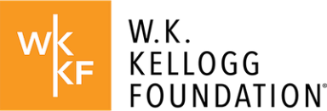
The W.K. Kellogg Foundation, founded in 1930 by breakfast cereal innovator and entrepreneur Will Keith Kellogg, is among the largest philanthropic foundations in the United States. Guided by the belief that all children should have an equal opportunity to thrive, WKKF works with communities to create conditions for vulnerable children to realize their full potential in school, work, and life. WKKF is based in Battle Creek, Michigan, and works throughout the country and internationally as well as with sovereign Tribes. Special attention is paid to areas with high concentrations of poverty where children face significant barriers to success. For more information, visit www.wkkf.org.
Established in 1996, the Doris Duke Foundation (DDF) works to improve the quality of people’s lives through grants supporting the performing arts, environmental conservation, medical research, and child well-being. DDF supports AFEM through its Child Well-being Program, which strives to strengthen and expand the capacity of social service systems that are collaborative and provide culturally appropriate, evidence-based, and context-specific prevention and treatment programs for parents and children. By strengthening the ability of existing social service systems to better serve those in places with sizeable inequities, more children and families can receive the essential supports and resources they need to pursue full, healthy, and happy lives. For more information, visit www.dorisduke.org.

McCann, Meghan and Josephine Hauer. “Whole Family Approach to Jobs: Helping Parents Work and Children Thrive: Lessons from the Field.” Washington, DC: NCSL, 2019.
“Advancing Family Economic Mobility.” https://www.familyeconomicmobility.com/.
The leadership team said that before the COVID-19 pandemic, six New England state teams, with state leads, were part of the WFAJ structure to advance economic mobility within states.
The ACF regional administrator for Region 1 and ACF regional program specialist also lead the WFAJ initiative in partnership with a consultant.
Kania John, Mark Kramer, and Peter Senge. “The Water of Systems Change.” Boston, MA: FSG, June 2018.
On March 13, 2020, President Trump declared a national emergency concerning the COVID-19 pandemic. On May 11, 2023, the national emergency for the COVID-19 pandemic expired.
Based on this feedback, the leadership team planned a two-day in-person learning community meeting in mid-May 2024.

