Issue Brief
Emily Metallic and Ryan Ruggiero June 2024

Advancing Family Economic Mobility in New England: A Regional Learning Community on Racial Equity
A Whole Family Approach to Jobs: Helping Parents Work and Children Thrive (WFAJ) is an initiative led by the U.S. Department of Health and Human Services’ (HHS) Administration for Children and Families Region 1 Office (ACF), in collaboration with the American Public Human Services Association (APHSA). Launched in 2017, the WFAJ initiative brought together public- and private-sector leaders from six New England states to work toward improving family well-being and economic mobility in their states. Now part of Advancing Family Economic Mobility (AFEM), an initiative committed to “creating sustainable pathways to economic mobility and well-being for all people and families,” the WFAJ connects federal and state New England leaders, including parents, in various ways: (1) an annual convening of state teams, usually held in person, (2) intermittent meetings with six states on emerging areas of interest related to economic mobility, and (3) topical learning communities on subjects of interest to the states, including parent engagement and leadership, racial equity and access, the child tax credit, and the benefits cliff effect.
This brief describes the activities of the WFAJ Racial Equity regional learning community from December 2021 through December 2023. It includes takeaways related to: (1) how the learning community’s leadership team planned and facilitated meetings, (2) meeting attendance, (3) how sharing and learning took place, (4) what participants learned and examples of how they collaborated, and (5) changes participants made to their practices, policies, and programs. Mathematica evaluated this learning community by observing its meetings, conducting focus groups with the leadership team, conducting focus groups and interviews with selected learning community participants, and administering a survey to learning community participants. A section on methodology at the end of the brief has more information.

Key takeaways
- Planning and facilitating meetings required the leadership team to create trust and safety in meetings to promote authentic peer sharing during meetings given the complexity and sensitivity of the topic. See page 5 for more information.
- An average of 15 participants from multiple state agencies attended each meeting, and 41 percent attended three or more of the 12 meetings. Participants were motivated to attend because they valued sharing and learning with other states, they wanted to develop a network of peers, and because of the federal government’s involvement in the learning community. See page 7 for more information.
- Participants agreed that attending learning community meetings deepened their understanding of policy options, best practices, and innovations for pursuing racial equity, including what other state governments are doing. See page 13 for more information.
- Participants reported they strengthened their relationships with and started collaborating more with other New England states outside of meetings. See page 15 for more information.
- All six states completed an assessment of their racial equity landscape to inform technical assistance needs, and participants are in the early stages of receiving this assistance. See page 16 for more information.
- Participants reported that they made, are in the process of making, or plan to make practice, program, or policy changes related to racial equity. For example, one state plans to review Temporary Assistance for Needy Families (TANF) participation and outcomes through an equity lens, rather than solely focusing on meeting TANF requirements. See page 17 for more information.
- Participants recommended that the learning community have a unified goal and state-developed resources to help them implement learnings in their own states. See page 19 for more information.

I. What is the Racial Equity Learning Community?
The New England regional Racial Equity Learning Community is a topical learning community within the WFAJ initiative. The learning community is facilitated by a leadership team made up of a consultant and a state co-lead. Two ACF staff, including the ACF regional administrator and an ACF regional program specialist, support the leadership team. The leadership team described the learning community as a peer-to-peer partnership in which state leaders share and learn best practices, innovations, and solutions related to advancing racial equity in their human services work. The purpose of this learning community is to help leaders in six New England states develop a long-term regional network of peers working to embed racial equity in their state human services agencies and deepen participants’ understanding of racial equity principles and best practices. The ultimate goal is that participants embed racial equity in practice, programs, and policies to improve outcomes for children and families.
“We’re stewarding the conversations [about racial equity].”
— Leadership team member
Key planned activities of the learning community include: (1) the leadership team plans and facilitates meetings; (2) participants attend and share best practices, innovations, and solutions with each other; and (3) the leadership team provides technical assistance outside of meetings to help participants apply and adapt learnings to their state context. As described in Figure 1, the leadership team believes that by engaging in these activities, state leaders will determine what steps they will take in their states to address racial equity.
“We have not succeeded very well at this issue [racial equity] over decades.”
— Leadership team member
Figure 1. Theory of change
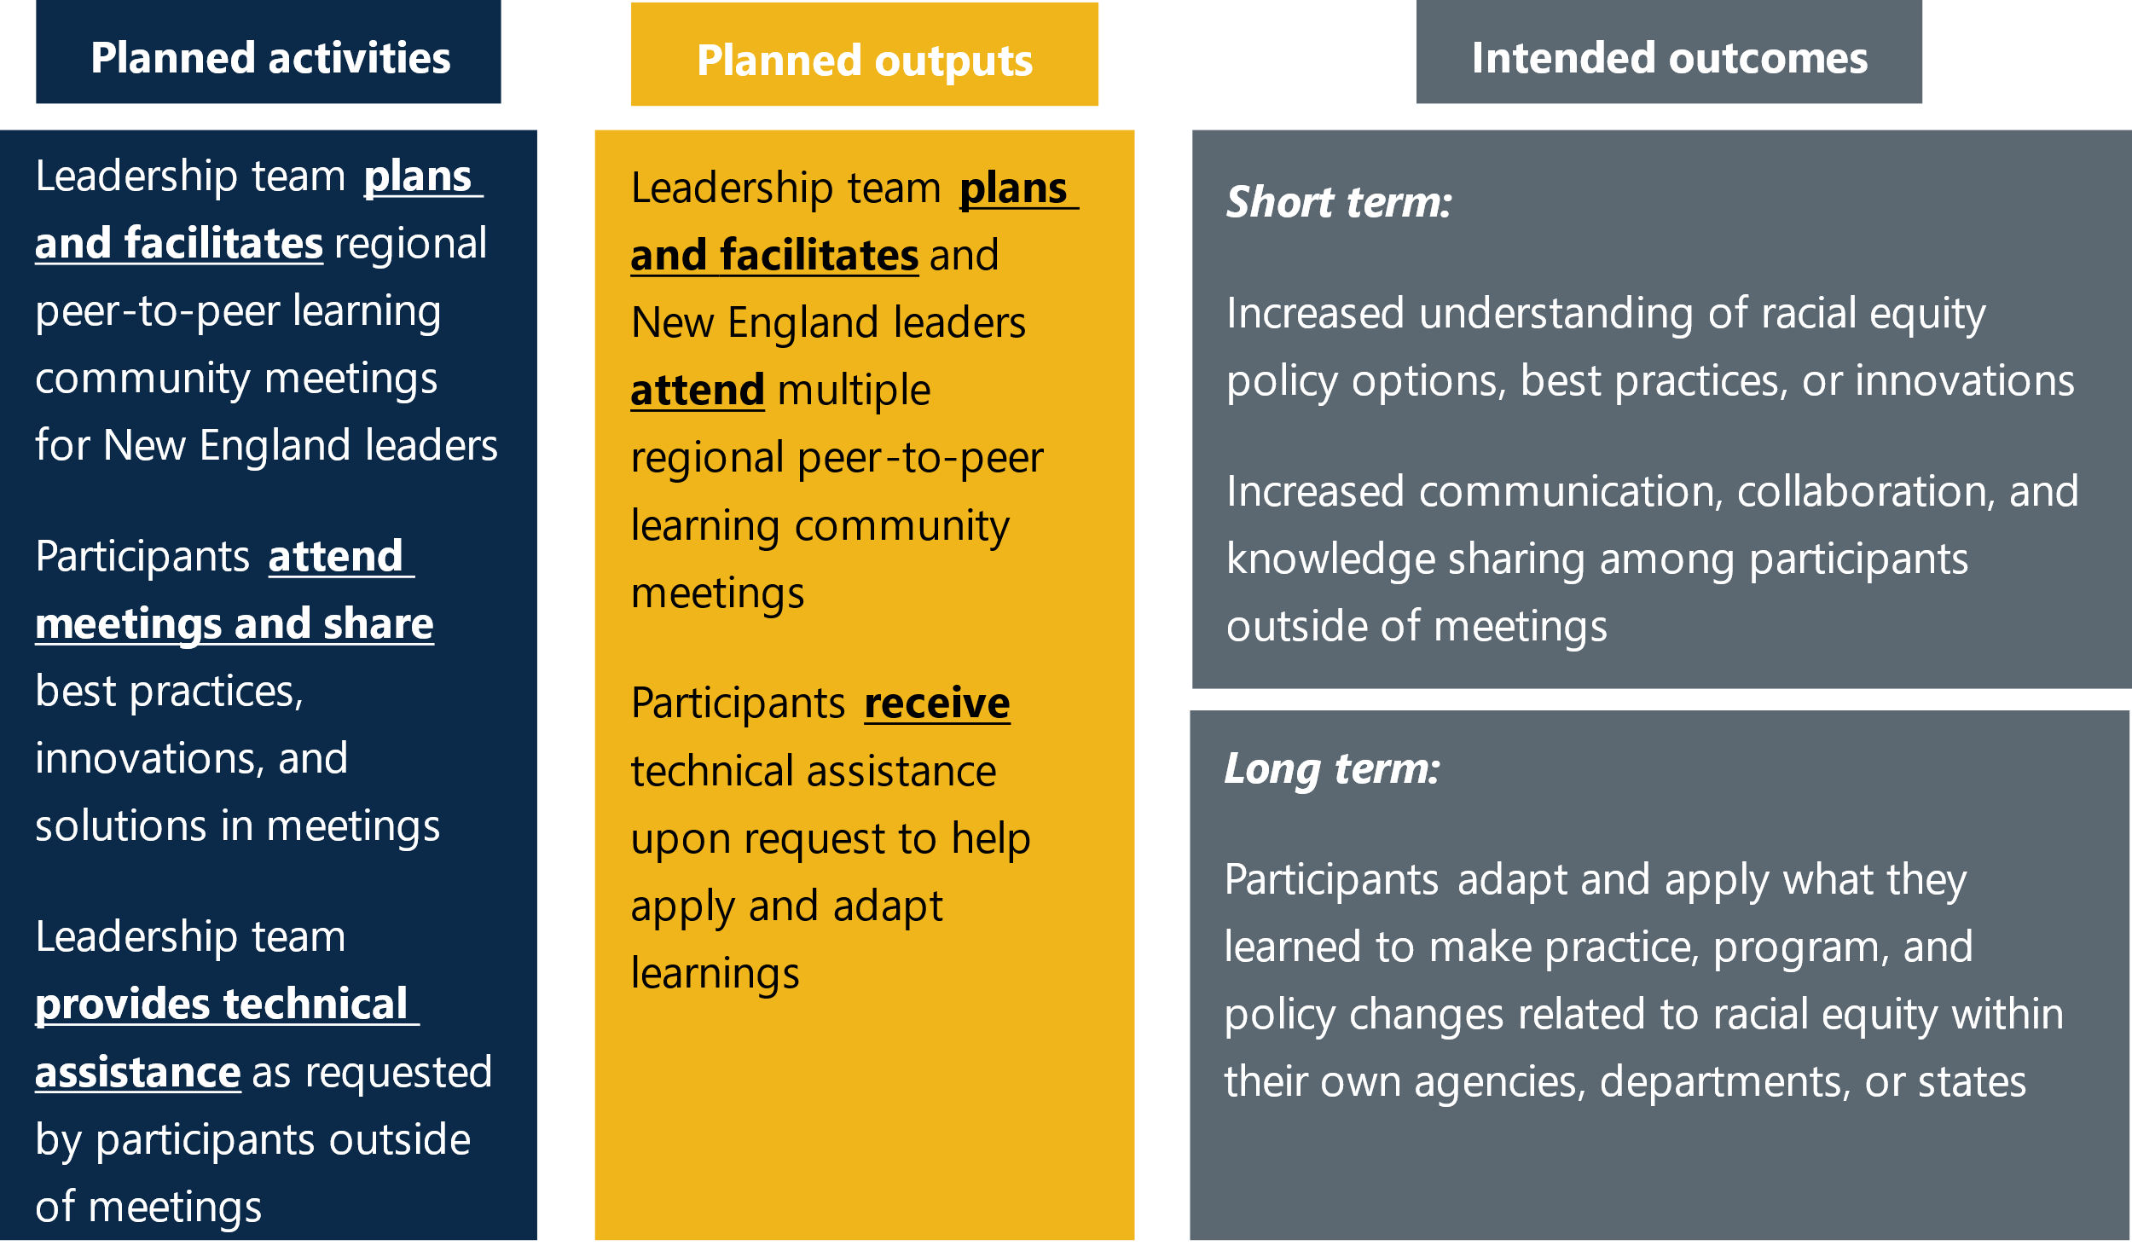

How was the learning community started?
The mission of ACF’s regional offices is to advise the ACF assistant secretary about state relations and cross-cutting, results-based strategic initiatives. The goal is to leverage public-private partnerships to improve outcomes for children and families. The leaders of the WFAJ initiative, two ACF staff and a consultant, launched the learning community in December 2021 in response to states raising racial equity as a topic of interest in six-state calls held in spring and fall 2021. Racial equity was also discussed at the WFAJ 2021 annual convening. The leaders of the WFAJ initiative said nationwide racial protests in 2020 and conversations about race heightened states’ interest in the topic, as did President Biden’s Executive Order 13985 on further advancing racial equity and support for underserved communities through the federal government. They also credited the ACF Strategic Plan, which prioritizes equity across ACF’s programs and practices, as supporting the establishment of the learning community.
Changing the human services systems within New England states
The regional learning community brings together human services state leaders across New England. A leadership team member said that state leaders determined what actions their state teams may take outside of learning community meetings to improve their state human services system. The leadership team said that before the COVID-19 pandemic, six New England state teams, with state leads, were part of the WFAJ structure to advance economic mobility within states. The leadership team said state leaders were overextended and exhausted during the pandemic due to managing a public health crisis and changing demands in service provision, making some state teams inactive or less active.
Although state teams were not the focus of Mathematica’s evaluation of the regional learning community, Mathematica facilitated virtual discussions in 2023 with two active New England state teams. The two teams were chosen by the leadership team, and the discussions were held to examine each state team’s strengths and areas for improvement related to factors likely to help their partnership achieve systems change.
What is systems change? Systems change initiatives aim to shift the conditions that hold a problem in place by changing policies, practices, resource flows, relationships and connections, power dynamics, and mental models (deeply held beliefs and thoughts).
Key takeaways from systems change assessments with two state teams
- During the virtual discussions with each state team, members indicated that their partnership showed readiness for systems change, identifying areas of strength and room for growth.
- Both state teams were strongest in multisector collaboration and alignment to support targeted outcomes and goals, and in sustainable resources and infrastructure. Both teams agreed that their partnership “fully” has: (1) structures and processes to facilitate active and genuine partner engagement, and (2) committed, diverse, and sustained funding. For example, one state team said there is a state budget line item for their state team’s work.
- Both state teams zeroed in on similar areas for growth: data infrastructure; trust and accountability; and equity in vision, mission, and action. Both teams thought they “somewhat” had: (1) an equity statement or goal, and (2) a concrete plan to improve outcomes; that (3) partners “somewhat” trust and hold each other accountable for implementing activities, and (4) there are “some” established norms and systems for data collection, management, and reporting across partners. For example, one state team believed they could do more to track and evaluate outcomes of their partnership, and another state identified an opportunity to have a comprehensive strategy with accountability measures for partners.
The learning community’s leadership team said that before its launch in December 2021, state human service agencies in New England had already committed to thinking more deeply about racial equity, including what it means to work toward racial equity and how their systems are structured. Describing the learning community as an “actualization” of states’ commitment to racial equity work, the leadership team said that states were learning in real time how to infuse racial equity into their work in human service agencies. A leadership team member underscored the importance of starting this learning community, saying, “We have not succeeded very well at this issue [racial equity] over decades,” and that the learning community provides a space to “steward those conversations.”

II. How did the leadership team plan and facilitate meetings?
From December 2021 through December 2023, the leadership team planned and facilitated 11 virtual learning community meetings on Zoom and one in-person meeting, for a total of 12 meetings. Leadership team members collaborated to create and refine meeting agendas informed by states’ interests. Although they were not part of the learning community’s leadership team, two ACF staff offered strategic and technical support to the learning community. Both staff consistently stayed informed about the work unfolding in the learning community. One staff member regularly attended learning community meetings, and the other had strategy discussions with the leadership team to guide the learning community’s direction. Similarly, although not part of the leadership team, a racial equity consulting firm joined the learning community in May 2023 to provide technical assistance to participants. The firm also supported the leadership team in planning and facilitating meetings, collaborating with them to determine who would lead different parts of the meeting. For example, they suggested and refined agenda topics based on findings from assessments they administered to states and on conversations they conducted with states outside of meetings.
How did partners support the WFAJ initiative?
Since its inception in 2017, WFAJ collaborated with a national organization acting as a strategic partner. WFAJ first partnered with the National Conference of State Legislatures and now partners with APHSA. APHSA supported the WFAJ’s annual convenings, provided technical and communications assistance, and compensated parent leaders who participated. The W.K. Kellogg Foundation and the Doris Duke Charitable Foundation funded the WFAJ initiative, along with local philanthropies, and assumed the costs of venue rental space, transportation, and food for the WFAJ 2024 in-person annual convening. APHSA also funded the WFAJ consultant who led the racial equity learning community and the racial equity consulting firm that joined the community in spring 2023.
The following takeaways describe how the leadership team planned learning community meetings and their recommendations for how to promote sharing and learning during meetings:
Adapt meeting agendas and meetings to participants’ needs and interests. The leadership team noted there is not one correct way to host a learning community. They said meeting agendas, for example, evolved in response to the current needs and challenges states faced. Before the racial equity firm joined the community, the leadership team regularly checked in with states about their racial equity interests and often ended meetings by asking states which topic they wanted to discuss next. The state co-lead ensured agenda items were relevant to states and considered whether states were ready to implement learnings.
According to a leadership team member, the racial equity firm administered assessments of each state agency’s racial equity work in summer 2023 and met with state teams outside of learning community meetings to discuss the necessary steps to advance racial equity work in their context. The leadership team and the racial equity firm used this information from states to inform and refine meeting agendas to reflect what was top of mind for participants. The lead consultant also had occasional calls with participants outside of meetings to gather feedback on the learning community and to understand participants’ priorities.
Create trust and safety to promote authentic disclosure and engagement. The learning community established ground rules for participation at its first meeting and revisited them when the racial equity firm joined the community. In learning community focus groups, participants all agreed that facilitators successfully fostered an environment of trust and safety among the group, allowing them to disclose challenges they were facing and receive support from fellow participants. Participants said breakout rooms without the consultant and federal staff allowed them to have some control over what they shared with federal staff, encouraging more authentic engagement from states. Participants also commended the leadership team for clearly communicating what information would remain confidential in meetings. This clarity facilitated deeper disclosure and discussion of what participants were working on and the challenges they faced related to racial equity in their agencies. The leadership team said meetings were purposely not recorded to promote safe sharing and learning, and they agreed there was clear communication around which discussions were confidential.
“I think that trust in the room was very important to be able to have candid conversations about what is going well or what is not going well when it comes to each state’s work to address racial equity.”
- Learning community participant

Prioritize opportunities for peer sharing and learning. The leadership team made sure to reserve at least half of the meeting time for peer sharing among states. The team said findings from Mathematica’s midline evaluation and learning checkpoint emphasized the value participants placed on hearing from each other, prompting the leadership team to prioritize peer sharing in meetings. Breakout rooms were used to facilitate smaller group discussions. The takeaways from the breakout room discussions were then shared with the larger group.
“For me, the most helpful thing has been being able to connect with other states and hear what their successes and challenges are, and seeing how much each state is grappling with some similar things. We are all trying to figure out how to navigate improving racial equity within the structure of government.”
— Learning community participant

Be a skilled facilitator who creates space for conversation and listens carefully. The leadership team stressed the importance of facilitation that sparks conversation and allows it to unfold. They said they stepped in as needed in their role as meeting facilitators to foster a sense of shared understanding among participants during meetings. They made sense of the conversation in real time to create the space for states to share with and learn from each other. For example, the leadership team regularly identified key points made by participants and synthesized common themes or connections in what different states were saying. The leadership team noted they made sure to listen carefully to what states said during meetings, given the deep complexity of the topic. A leadership team member said that although they are not a racial equity expert, they have enough training related to racial equity to appreciate the importance of careful listening that “honors people’s perspectives.”

III. Who attended learning community meetings?
“Racial equity requires you, as a facilitator, to have enough context around racial equity to not be a bull in a china shop in any way, shape, or form ... The complexity around racial equity is deep.”
— Leadership team member
The leadership team met with executive branch leaders of human service agencies in New England who helped identify staff to join the learning community. The leadership team then invited those staff to join the learning community. At times, those staff may have invited another agency staff member to a meeting.
The leadership team limited the number of participants to promote trust and ensure a safe space for discussing racial equity. The racial equity learning community was intentionally kept small because the leadership team thought a smaller group would help build trust and safety. The leadership team said they wanted to ensure safety to promote authentic sharing on a sensitive topic. A smaller group with consistent attendance reduced the need for repetitive explanations of the ground rules with new attendees and allowed participants to develop a shared understanding of racial equity. A smaller and more consistent group facilitated deeper, more nuanced conversations, keeping members who were well versed in racial equity engaged.
Meeting participants were primarily from state agencies and had a range of authority levels. Attendance records show that a majority of meeting participants were New England state human services staff. Other attendees included guest speakers from a nonprofit organization and city government along with the leadership team. In May 2023, as noted, staff from a racial equity consulting firm began attending meetings. Of the participants (other than guest speakers) for whom data were available, approximately three-quarters (76 percent) were from a state agency, and 14 percent were from a federal agency.
State agency participants came from various departments including TANF, Training and Diversity, Equity and Inclusion, and Race, Equity, and Community Engagement. State agency participants had positions with a range of authority levels, including associate commissioners, policy directors, outreach specialists, and department directors. Some participants in the learning community focus group said their positions did not give them the authority to implement certain discussed changes. On the other hand, one participant said they valued the diverse representation of program directors and middle managers in meetings, as it fostered different discussions than there would have been with only commissioners present.
“The equity world's there and [that changes] how the conversations get driven, [and] how connections get made change. And then that kind of deepens the work, and it helps us spread [our racial equity work] because it's not in isolation or in this defined box [consisting only of WFAJ initiative members].”
— Learning community member
Almost half of meeting participants attended three or more meetings. In the first year, the leadership team facilitated eight virtual meetings; in the second year, there were three virtual meetings and one in-person meeting in spring 2023. From December 2021 to December 2023, an estimated 39 participants attended at least one learning community meeting, with an average of 15 participants in each meeting. Of the 39 participants who regularly attended meetings, 41 percent (16 participants) attended three or more meetings, 23 percent (9 participants) attended two meetings, and 36 percent (14 participants) attended one meeting.² The leadership team said they were generally satisfied with the number and mix of participants in each meeting.
Figure 2. Types of participants and their attendance rates
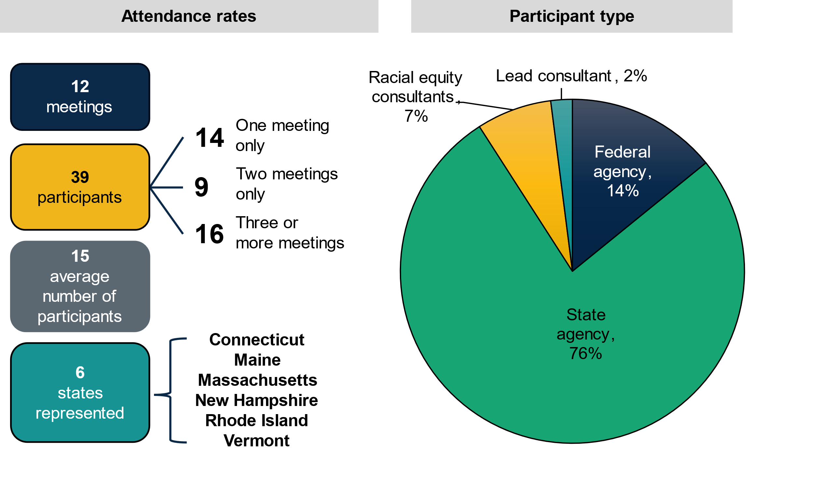
Note: Attendance records reflect meeting attendance between December 2021 and December 2021 and exclude guest speakers, racial equity consultants, and ACF interns because they were not invited to every meeting. Participant type excludes guest speakers.

Examples of represented agencies that attended at least one learning community meeting
- Massachusetts Department of Transitional Assistance
- Rhode Island Department of Health and Human Services, Race, Equity, and Community Engagement
- New Hampshire Department of Health and Human Services, Office of Health Equity
- Maine Department of Health and Human Services, Office for Family Independence
- Vermont Department for Children and Families
- Vermont Reach UP (state TANF program)

What challenges did the leadership team face in planning meetings?
- Turnover in the state co-lead, a member of the leadership team. During the evaluation, the state co-lead, a member of the leadership team, changed twice because both people in the position left their state agencies. A member of the leadership team said the second state co-lead was sometimes difficult to engage given their state role, which affected planning at times. In February 2024, the second state co-lead left their position in the state legislature, and subsequently left the leadership team.
- Difficulty securing an expert in racial equity. The leadership team said they wanted to have a racial equity consulting firm join the learning community sooner than May 2023 to respond to participants’ desire to dive deeper into racial equity and to receive technical assistance. However, a pending contract fell through with a different firm, which delayed the leadership team in securing a contract.
- Limitations of virtual meetings in creating trust. The leadership team also acknowledged it was challenging to create the trusting environment necessary for discussing racial equity through virtual meetings, which may have made it difficult for participants to get to know each other. To build trust, the leadership team helped the group establish ground rules and structured meetings, with breakout rooms to allow confidential conversations among participants. The leadership team also prioritized having an in-person meeting in spring 2023 to help build trust among participants.
Competing priorities also made it difficult for the leadership team to plan and for participants to attend meetings. The leadership team and learning community focus group participants both described juggling multiple work priorities as barriers to planning and attending meetings. The leadership team said busy schedules and limited capacity made it challenging to find the time they needed to plan meetings. They emphasized the effect of the COVID-19 pandemic on both federal and state government workload and priorities. The leadership team said that during the pandemic, government staff were exhausted from managing a public health crisis that took their full attention. At the same time, the leadership team said there is a worker shortage in state government, making it difficult for state leaders to consistently attend meetings. Learning community participants similarly said they sometimes had to miss meetings because an urgent matter came up at work. The leadership team had hoped some states would have staff with higher authority at the learning community meetings, but state staff turnover proved to be an issue.
Participants suggested ways to overcome meeting attendance challenges:
- Ask another colleague to attend,
- Send meeting agendas in advance, and
- Scheduling meetings in advance.
Participants said having the agenda in advance helps them prioritize the meeting, or allows them to find someone else who can attend on their behalf. One learning community member would have liked the agendas to be more fleshed out and shared with participants earlier so they knew what to expect and could come to meetings more prepared. They shared, “Sometimes there would be very little lead time; there would be a calendar invite far in advance, but sometimes the practical guidance [in the agenda] felt a little thin or late.”

What motivated participants to attend meetings?
In focus groups and interviews, learning community participants discussed what motivated them to attend learning community meetings.
Desire to build a broader network of peers to learn from and share with about racial equity. Focus group participants were eager to meet others who were implementing the work in practice and learn from them. They emphasized that hearing from other states during meetings was a driver of attendance. The leadership team noted that racial equity work can be isolating and challenging, and it is important to develop a network of colleagues to serve as sounding boards for problems they face.
“I enjoy attending [meetings] because it really empowers me, and I get to see that I'm not the only one going through the same things. I call it sometimes a little bit of a therapy session.”
— Learning community participant

Federal government’s convening of the learning community. Federal ACF staff helped create the learning community, and they provided strategic support to the leadership team. All focus group participants agreed the federal government’s convening of the learning community was a positive motivating factor for attending meetings. Participants said without the federal government’s coordination, this learning community would not have met as regularly or as smoothly. They thought the federal government’s leadership on the subject signaled to state agency leaders the importance of racial equity.
Organizational and personal interest in advancing racial equity. Focus group participants said racial equity was a priority for their agency leadership and was relevant to their state agency’s work, so they welcomed having a dedicated space to learn more about this topic. Participants appreciated learning about the work other communities and agencies were doing related to racial equity because it helped them generate ideas for work their state might be able to do and helped them realize how to address challenges they faced. Participants said they wanted to build their toolkit of best practices for embedding racial equity in their work. They also enjoyed sharing their experiences and informing the work of other states and the federal government.
“What we are interested in doing as a state, or at least as an organization, is being reflective and acting around equity. [The learning community] is just useful by default.”
— Learning community participant

IV. How did sharing and learning happen during meetings?
Learning community meetings gave participants a space to share and learn best practices, innovations, and solutions with each other in real time. Each meeting lasted about 75 to 90 minutes and included presentations on various racial equity topics. The leadership team sometimes presented topics for discussion in meetings; guest speakers and the racial equity firm also presented during meetings. Each meeting typically included time for small breakout groups, each with participants from two to four states. In the breakout groups, participants discussed key questions proposed by the leadership team and shared what they were doing and learning in their agency related to racial equity. The leadership team said at least half of the meeting time was dedicated to breakout groups, reflecting the leadership team’s commitment to peer sharing and learning. All focus group participants said they were satisfied with the amount of sharing at the meetings. They said virtual meetings were convenient and allowed more people to attend meetings, but they valued the in-person meeting for forming personal connections and letting them go deeper with the work.
Meeting topic in focus: Procurement
Embedding racial equity into procurement practices was a topic of focus for three learning community meetings in 2022. A member of the leadership team said the states chose to focus on procurement for several meetings because many human service agencies use procurement as a tool to deliver services by awarding contracts to organizations and businesses. They said making changes to states’ procurement processes can help address racial disparities by making the procurement process more accessible and equitable to smaller minority-owned organizations and businesses that work directly with communities and are often excluded from government procurement. For example, smaller organizations and businesses may find it difficult to access large government bids and may not have the resources to manage government payment delays and time frames, or the required bonding or insurance capabilities. The state co-lead introduced the topic to share their agency’s experience reviewing ways to embed racial equity principles into TANF procurement processes by structuring procurements differently to enable smaller and minority-owned organizations and businesses to compete for state contracts. Participants reviewed the resource A Procurement Path to Equity to discuss strategies for equitable contracting and procurement, and agreed procurement was a relevant topic to discuss in the learning community. In one meeting, the leadership team invited a guest speaker from Living Cities to share lessons learned and trends in equitable procurement. In subsequent meetings, guest speakers from city government in Knoxville, Tennessee, shared how they hold departments accountable for increasing diversity in procurement contracts; and guest speakers from Los Angeles County, California, offered an overview of how they restructured their procurement processes, which led to more businesses and organizations from minority communities working with the county.
“Procurement is how many states deliver human services, and there is a growing recognition that procurement processes, and changing them, [are] key to reducing disparities.”
— Leadership team member
Agenda topics included policy levers to bring racial equity into state agencies’ work; equitable contracting and procurement; how to engage leadership and partners in technical assistance on practicing racial equity; a discussion of the states’ racial equity assessments; and transactional versus transformational leadership.

What helped participants share and learn during meetings?
In focus groups and interviews, learning community participants discussed what helped them share and learn during learning community meetings.
A meeting culture of trust promoted sharing. Focus group participants credited the leadership team with helping develop trust among participants, which was integral to genuine sharing. “This [racial equity] is a sensitive topic for many,” one participant acknowledged. Participants appreciated the clear communication around what was and was not confidential, which helped them speak more openly about challenges they were facing. The leadership team said they intentionally tried to build trust among participants by encouraging deeper conversations about challenges and encouraging participants to support each other.

“The facilitation…made a safe space which allowed me to open up about some challenges that I was having.”
— Learning community participant

Meeting structure provided the opportunity to hear from and share with other states. Focus group participants said the leadership team structured meetings in a way that promoted sharing and learning with their peers, noting they learned best from their peers during meetings. Participants said breakout sessions with a smaller group allowed for in-depth conversations, peer sharing, and time to solve specific issues directly with other state agencies. They said meetings were “well structured.” Several participants would like even more time to hear from and share with other participants.

“There is something energizing and catalyzing about being able to talk with our neighbors around us about what is happening, how to address things.”
— Learning community participant

Some participants wanted a common goal and shared sense of direction to promote learning about how to implement racial equity work. Although all focus group participants were satisfied with the amount of sharing, some were unsatisfied with the kind of learning. These participants found it challenging that the learning community did not work toward a common goal. Those who expressed a desire for a shared goal said that without one, they found it difficult to know what to share at meetings. They also said they would have appreciated seeing examples of materials from other states, like surveys or training materials, to have concrete examples of work to model and implement in their own state context. Others were satisfied with the flexibility that allowed states to share freely with each other about their state’s work.

V. What did participants learn during meetings?
A desired short-term outcome of the learning community is that, by attending meetings, participants will deepen their understanding of policy options, best practices, or innovations related to racial equity. Mathematica sent an endline survey to learning community participants in January 2024—not including the leadership team—to understand what they learned during meetings. Four participants from three states responded to the survey. As shown in Figure 3, three of four learning community participants who responded to the survey agreed that participating in the learning community increased their understanding of policy options, best practices, or innovations to embed racial equity into state programs and policies.
Figure 3. Knowledge gained about racial equity
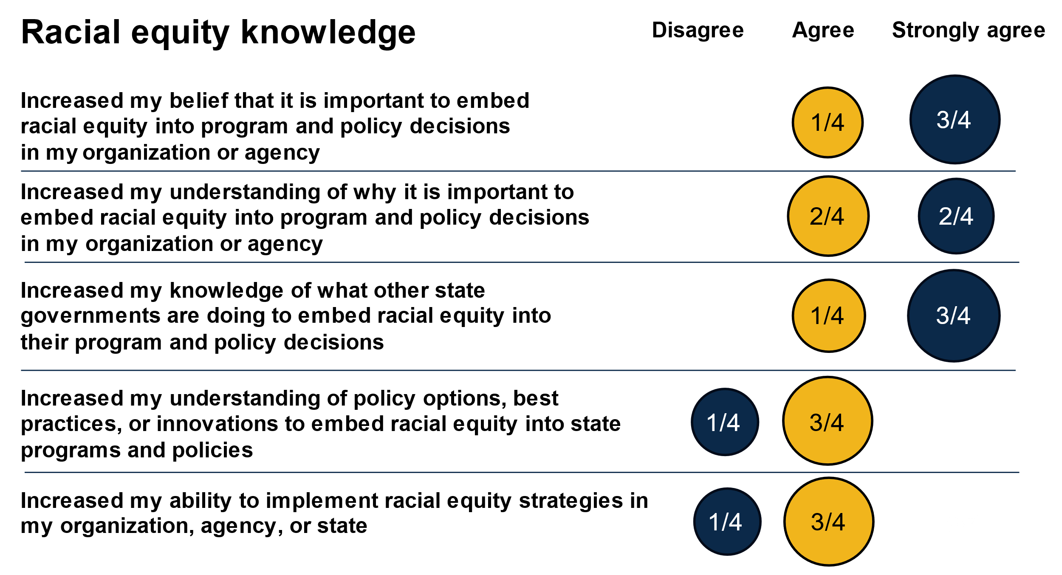
Participants learned what other state governments are doing to embed racial equity into their program and policy decisions. All four survey respondents agreed or strongly agreed that participation increased their understanding of the current racial equity landscape in New England states. Learning community focus group participants said it was helpful to hear examples from other states about both the challenges they were facing and the work they were pursuing despite those challenges. Focus group and survey respondents said meetings developed their awareness and understanding of what racial equity work was happening in their region. Participants also said they learned who was doing racial equity work in each state, so they knew whom to reach out to for input on work they were implementing in their own state.
“Seeing a state that has the same concerns as ours moving heavily forward in the work of racial equity is a guiding light of possibilities that we could make happen in [our state].”
— Learning community participant
All four survey respondents agreed or strongly agreed that participating increased their belief in and their understanding of how important it is to embed racial equity into program and policy decisions in their agencies. The leadership team said racial equity is a topic area everyone enters with different lenses and levels of understanding, and they worked to build a shared understanding of the topic among the group. For example, one focus group participant said they now think about racial equity as something to embed more broadly across their organization; before, they thought about advancing racial equity within the scope of their role. This participant said they were more aware they need to build buy-in for racial equity as an anchor in the work they do among a wider group of leaders, instead of concentrating racial equity work in one or two positions. This helps ensure the work continues despite staff turnover or leadership changes.
“With some of the other work groups for this [WFAJ initiative], like with benefit cliffs and parent engagement, I think there was … a clearer line to say, ‘This is what we've been working on as a region.’ I don't think we have that same equivalent here for racial equity ... Parent engagement is a very specific topic. This one [racial equity] is a very broad topic that affects everything, so it is hard to drill down.”
— Learning community member

Learning checkpoints to advance continuous learning and improvement
Once during the evaluation (November 2024), Mathematica conducted a learning checkpoint to promote action-oriented and timely opportunities for the leadership team and participants to improve the learning community. Mathematica led the checkpoint during a learning community meeting, collected feedback from participants through MURAL, analyzed the feedback, and shared findings with the leadership team in a follow-up email. Participants noted the following strengths and growth opportunities for the learning community at this checkpoint:
- Areas of strength. Participants want to keep meeting, and they valued opportunities for conversations during meetings about what is happening in each state.
- Areas of growth. Participants would like a clearer regional focus area or practice, want to see more state staff invited to meetings, and would like more tools and materials to communicate effectively about this work with colleagues and across silos.
In addition to learning checkpoints, Mathematica conducted and shared midline evaluation findings in spring 2023 with the leadership team and learning community members. The leadership team said they used these findings to inform subsequent learning community meetings.
Some participants learned policy options, best practices, or innovations to embed racial equity into state programs and policies, and some participants wanted more actionable examples to apply to their work. Three of four survey respondents agreed that participating in the learning community helped them understand more about policy options, best practices, or innovations to embed racial equity into state programs and policies. For example, one focus group participant said the Government Alliance for Racial Equity (GARE) model shared in a meeting changed the way their state agency thinks about the importance of a vision for racial equity, which is informing their strategic planning. Some participants, however, expressed a desire for more actionable knowledge they could apply to their state work, instead of focusing on a comprehensive strategy that could take “years and years and years” to achieve. Participants thought focusing on a comprehensive racial equity strategy instead of specific goals could be challenging because the broader political environment shifts. One participant said, “Leadership culture around racial equity work goes through peaks and valleys in terms of how it’s prioritized.” Another participant pointed out that transforming government is not something anyone in any of the participants’ positions can achieve, but they could realistically make progress on a more specific goal, such as providing more culturally and linguistically competent services to clients or cultural awareness trainings to customer-facing staff.

VI. How did participants collaborate with each other outside of meetings?
A desired short-term outcome of the learning community is that by attending meetings, participants will communicate, collaborate, and share knowledge with each other more often outside of meetings. Survey responses indicated that some participants strengthened their relationships with each other, and that collaboration was happening outside of meetings.
Participants reported stronger relationships with other New England states and federal partners. All four survey respondents agreed or strongly agreed that participating in the racial equity learning community strengthened their relationship with other New England states. One focus group participant said the learning community was a “relationship builder.” Another focus group participant said the main benefit of the learning community was “opening up channels of communication to other states and looking outside of our own borders for questions or models or conversations.”
Three out of four survey respondents agreed or strongly agreed that participating in the racial equity learning community strengthened their relationships with federal agencies. One focus group participant said the learning community served as an “impetus to reengage with [ACF]” after a drop-off in that relationship over the past year and a half. They said the learning community was particularly helpful to “demonstrate and reinforce the value [of ACF],“ to some colleagues who viewed their engagement with ACF as “just another thing.”
Participants reported more collaboration related to racial equity outside of meetings with other New England states. Three of four survey respondents reported an increase in collaboration related to racial equity outside of the learning community meetings with other New England states. For example, one participant attended a racial equity training being held by another New England state after another participant invited them. Increased communication outside of meetings was the most common form of collaboration related to racial equity that survey respondents reported engaging in with other New England states.
“I really appreciate the other states being available [to have further conversations]. If it wasn't for this platform, those kinds of connections and relationships would never been developed.”
— Learning community member

VII. What type of technical assistance did participants receive?
To help change practice, programs, and policies related to racial equity, the leadership team planned to provide technical assistance outside of meetings by participant request. They did not offer technical assistance in the first year of the learning community, but in the spring 2023 in-person meeting, the leadership team conducted a mapping exercise with participants. The purpose of the mapping exercise was for participants to inform their peers of their racial equity work by describing what their agency was doing related to racial equity policy and practices. In response to the states’ request for deeper technical assistance, in May 2023 the leadership team hired a racial equity firm to provide technical assistance to participants at no cost to state agencies; APHSA funded this work.
A contracted racial equity firm assessed the racial equity landscape in six states to inform technical assistance needs. A racial equity consulting firm created an assessment of each state agency’s racial equity work based on the GARE model. They distributed the assessment to participants to better understand where their agency was on its journey to advance racial equity, to identify barriers to the work, and to help determine a starting place for technical assistance with each state team. Participants shared the assessment with multiple staff within their departments and agencies. All six New England states completed the assessment, and state participation levels varied, with between three and 25 staff members contributing to the assessment. The racial equity firm analyzed assessment results to evaluate where each department or agency was in the GARE framework of advancing racial equity, and produced detailed reports for each state. The racial equity firm held calls outside of learning community meetings with state teams to discuss the assessment results; however, some state teams have not yet had these calls due to scheduling and workload issues.
“We know systems change and reform is slow, but backing up and cataloguing all the change in [our state], I’m very proud of us as a state in terms of how much we've done so far to advance our equity practices. Taking the time to do the mapping and looking at the full landscape of the work was an important activity.”
— Learning community participant
Participants are in the early stages of receiving technical assistance to advance their state’s racial equity work. The leadership team said the goal of the assessment was to help state teams decide what should happen next in the area of racial equity, to support their individualized technical assistance. A couple of state agencies already had racial equity road maps, but they were not being operationalized because they did not have sufficient resources to carry out the work, even though they had leadership buy-in. In response, the racial equity firm presented on how to be a transformational rather than a transactional leader at a learning community meeting. The leadership team noted that vision setting and leadership buy-in will likely be the focus of future technical assistance. The leadership team said the hope for future technical assistance is to create roadmaps for state teams about how they will build on the work in the learning community with concrete products and processes. One state opted out of receiving technical assistance after the assessment because the state already had a task force actively working on a comprehensive plan for racial equity and did not want to duplicate efforts.
“The value [of the learning community] has increased because the real reflection and work, the understanding and figuring out how to apply that to our processes—that has come out of the racial equity firm’s conversations. We have used that now in a variety of spaces, and we keep going back to it—whether we're talking about our strategic plan, or we're talking about equity work in the department, or we're talking about the way we frame systems change.”
— Learning community participant

What helped participants receive technical assistance, and what hindered them?
Learning community participants said the federal backing of the technical assistance facilitated buy-in from their state agency leaders, and it was also helpful that the technical assistance came at no cost to states. Learning community participants reported staffing changes and shortages were a challenge to receiving technical assistance. One state was unable to engage with the racial equity firm beyond an initial assessment, and another was unable to conduct pre-work before meeting with the firm, which participants said limited the effectiveness of their meetings. Another challenge one participant highlighted was a desire to receive technical assistance to help solve their problems rather than identify what they were. The technical assistance they received stopped at the assessment due to staffing changes that prevented them from building out a work plan with the racial equity firm based on the assessment, but they were interested in receiving targeted guidance to address problems that surfaced in the assessment.

VIII. What changes did participants make at their agency, organization, or state level?
The intended long-term outcome of the learning community is that participants embed racial equity in practice, programs, and policies to improve outcomes for children and families. The leadership team acknowledged that making progress on racial equity can take decades, and states are at different places in their levels of understanding of and engagement with racial equity work. Likewise, some participants said internal challenges like limited staff capacity restricted their ability to carry out the work. Still, some focus group participants gave examples of how knowledge gained in learning community meetings informed their work outside of meetings.
All four survey respondents reported that their agency or state is in the process of changing or is planning to change its practices, programs, or policies. Three out of four survey respondents said they were working on a change, and one planned to make a change related to something they learned in the meetings. All surveyed learning community participants said attending racial equity learning community meetings was somewhat or very helpful in changing their practices, programs, or policies based on what they learned. They all also reported that having outside speakers who attended meetings, receiving technical assistance to apply what they learned, and collaborating with other states were somewhat or very helpful in making changes. Other factors that all four respondents said were somewhat or very helpful in making practice, program, or policy changes included racial equity being a policy priority for their organization, agency, or state; support on racial equity from agency leadership; and meeting with colleagues in their agency or another agency in their state. One focus group participant said their state leadership’s “adamance that we do it [racial equity work]” was crucial to moving the work forward.
“I’m very proud of us as a state in terms of how much we've done so far to advance our equity practices. [We are] really looking at adhering to a mission and a value statement and organizing a plan.”
— Learning community participant

Participants shared examples of practice, program, or policy changes that their organization, agency, or state made or is considering making based on something they learned in the community:
- Practice change. One state is using the GARE framework, introduced by the racial equity firm, as a core component of its organization’s strategic planning process to incorporate racial equity. The framework is shaping the state’s conversations on the importance of having a vision related to racial equity.
- Practice change. One state reviewed its contracting and procurement process to engage historically marginalized groups in the procurement process.
- Planned change. One state committed to looking at participation and outcomes within its TANF employment program through an equity lens, whereas before, the focus was solely on meeting TANF requirements. Although still in an early phase of this shift, the state created an action plan and has started implementing it.
- Planned change. One participant was inspired by another state’s use of affinity groups to bring together colleagues from marginalized communities to discuss shared concerns, experiences, and priorities. Their agency’s leadership has expressed buy-in for this practice of establishing affinity groups
“That [action plan] is something that I am very proud of, because it’s a different way that we look at TANF outcomes in terms of meeting the requirements of TANF versus really trying to look at outcomes through an equity lens as a whole family.”
— Learning community participant
Survey respondents noted a variety of barriers to implementing what they learned by changing practices, programs, or policies. All four survey respondents said these barriers included insufficient funding to implement learnings and difficulties changing organizational culture. Three of four survey respondents said they faced the following challenges: not having enough time or capacity in their daily schedule to move the work forward, not collaborating with other states outside of meetings, and staffing changes. The leadership team noted that staff turnover was a significant challenge for participants. For example, one participant had three different roles in six months; the challenge of learning a new job takes time away from racial equity work.

IX. What’s next for the learning community?
The leadership team plans to continue the learning community in 2024 by hosting meetings in April and June. Although there is not funding for the learning community past June, the leadership team said the states will decide if they want to continue the learning community in the June meeting. The leadership team is aware of at least one state’s interest in narrowing the focus of the learning community by identifying a common goal across all six states.
Participants had the following recommendations for the learning community:
- Share agendas in advance that highlight whom states can invite to meetings and what they should do to prepare for meetings.
- Share more state-developed resources to promote a better understanding of how to operationalize racial equity work.
- Use technical assistance in a more tailored way to find solutions to problems states are facing.
- Create a unified, realistic goal the region can work collectively toward achieving.

Methodology
The findings in this brief are based on data Mathematica collected between February 2022 and February 2024, including: (1) three focus groups with the racial equity leadership team in January 2022 (baseline), January 2023 (midline), and January 2024 (endline); (2) two focus groups with learning community participants in February 2023 (midline) and four individual interviews with learning community participants in February 2024 (endline); and (3) an endline survey distributed to learning community participants in January 2024. Mathematica also collected and analyzed learning community attendance records, observed at least two learning community meetings each year, and reviewed meeting agendas and notes when provided.
One leadership team member attended all three focus groups; the state co-lead attended the midline focus group; and the two federal ACF support staff attended the baseline and endline focus groups. The racial equity firm did not participate in any focus groups or interviews. A total of nine learning community participants attended either one focus group or an interview. Mathematica considered attendance rates at learning community meetings and a mix of states when selecting learning community participants to invite to focus group discussions. Some learning community participants did not respond to Mathematica’s invitation.
A total of four learning community participants completed the endline survey in January and February 2024. Mathematica sent the endline survey to learning community participants who attended at least two learning community meetings between December 2021 and December 2023 (a total of 18 participants), making the survey response rate approximately 22 percent. At least one person from New Hampshire, Rhode Island, and Vermont participated in the endline survey; no one from Connecticut, Maine, or Massachusetts responded. Two of the four survey respondents identified as White; the other two respondents listed either “other” or “prefer not to respond” for their race. Three of four survey respondents were between the ages of 46 and 59, and three identified as female.
Equitable evaluation practices
At various points throughout the evaluation, Mathematica engaged members of the Research Advisory Council (RAC) to inform data collection tools and analysis. The leadership team is part of the RAC, and they selected learning community participants to join the council. Mathematica met with the council and requested written feedback. Examples of how the RAC contributed to evaluation efforts include providing input on:
- The learning community survey
- The systems change questions
- Focus group discussion guides
- Midline evaluation findings
Mathematica also conducted a separate virtual meeting with two state teams in spring 2023 to discuss each team’s readiness for systems change. The leadership team selected two state teams to participate in the virtual discussions. In these discussions, Mathematica asked questions using a framework developed by Mathematica and Equal Measure—the Self-Assessment of Place-Based Systems Change Efforts—which the Research Advisory Council tailored to fit the state context. Mathematica facilitated the discussion with each state team by asking questions from the assessment, having state team members to talk with each other to agree on one of the following responses to each question: “not at all,” “some or somewhat,” or “a lot/fully.” Each hourlong discussion included five state team members. In one state, Mathematica held an additional 30-minute discussion.

Acknowledgments
The authors thank the WFAJ leaders including Elaine Zimmerman and Josie Hauer and members of the learning community leadership team for their input on planning the evaluation. They also thank the Research Advisory Council members including Jennifer Beck, Erin Quinn, and Christine Tappan for their input and guidance throughout the evaluation. The authors thank Brandy Whisman, Jennifer Kerr, Christina Becker, and Ann Flagg at APHSA. The authors thank the learning community participants. The evaluation would not have been possible without their feedback on the learning community through focus groups, interviews, surveys, and allowing Mathematica staff to attend and observe their meetings.
Lastly, the authors thank Aden Bhagwat and Elizabeth Mugo for their note-taking support, Marykate Zukiewicz for project management support, Jon McCay and Matt Stagner for their guidance and quality assurance review, Effie Metropoulos for editorial support, Sheryl Friedlander for production support, and Jon Owolabi for graphics support.

About Advancing Family and Economic Mobility
Advancing Family and Economic Mobility (AFEM) is an initiative of APHSA that is committed to creating sustainable pathways to economic mobility and well-being for all people and families. The AFEM network fosters new approaches to improving long-term, systemic economic mobility at all levels. To achieve this, AFEM is building a vetted repository of reproducible strategies and resources to share with agencies throughout the United States. For more information, visit www.familyeconomicmobility.com.

In partnership with
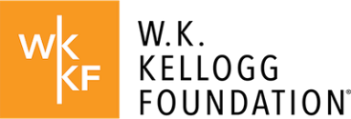
The W.K. Kellogg Foundation, founded in 1930 by breakfast cereal innovator and entrepreneur Will Keith Kellogg, is among the largest philanthropic foundations in the United States. Guided by the belief that all children should have an equal opportunity to thrive, WKKF works with communities to create conditions for vulnerable children to realize their full potential in school, work, and life. WKKF is based in Battle Creek, Michigan, and works throughout the country and internationally as well as with sovereign Tribes. Special attention is paid to areas with high concentrations of poverty where children face significant barriers to success. For more information, visit www.wkkf.org.
Established in 1996, the Doris Duke Foundation (DDF) works to improve the quality of people’s lives through grants supporting the performing arts, environmental conservation, medical research, and child well-being. DDF supports AFEM through its Child Well-being Program, which strives to strengthen and expand the capacity of social service systems that are collaborative and provide culturally appropriate, evidence-based, and context-specific prevention and treatment programs for parents and children. By strengthening the ability of existing social service systems to better serve those in places with sizeable inequities, more children and families can receive the essential supports and resources they need to pursue full, healthy, and happy lives. For more information, visit www.dorisduke.org.

McCann, Meghan and Josephine Hauer. “Whole Family Approach to Jobs: Helping Parents Work and Children Thrive: Lessons from the Field.” Washington, DC: NCSL, 2019.
Advancing Family Economic Mobility.” https://www.familyeconomicmobility.com/
The leadership team said that before the COVID-19 pandemic, six New England state teams, with state leads, were part of the WFAJ structure to advance economic mobility within states.
During the evaluation, the composition of the leadership team changed. In April 2022 the state co-lead left their agency, and a new state co-lead replaced them as a member of the leadership team. Then, in February 2024, the second state co-lead left their position in the state legislature and subsequently left the leadership team, without a replacement.
The ACF regional administrator for Region 1, ACF regional program specialist also lead the WFAJ initiative in partnership with the consultant who is part of the Racial Equity Learning Community leadership team.
Kania, John, Mark Kramer, and Peter Senge. “The Water of Systems Change.” Boston, MA: FSG, June 2018.
Although outside the time frame of this evaluation, the leadership team confirmed that an additional in-person meeting occurred in April 2024 and another is planned for June 2024.
Participant type excludes guest speakers.
Meeting attendance rates exclude guest speakers and ACF interns, who were not regularly invited to attend meetings. Racial equity consultants are also excluded because they joined the group in spring 2023.
On March 13, 2020, President Trump declared a national emergency concerning the COVID-19 pandemic. On May 11, 2023 the national emergency for the COVID-19 pandemic expired.
Although outside the time frame of this evaluation, the leadership team confirmed that an additional in-person meeting took place in April 2024, and one is planned for June 2024.

